

2022-2025 Hyundai Palisade 1.5" lift kit installation guide
Professional installation recommended
IMPORTANT!
Lifting and modifying the suspension on your vehicle may result in drive line vibrations, damaged bushings, erratic handling characteristics, and shortened suspension component life. HRG Offroad recommends the following:
-Checking and/or replacing worn drive axles with new parts, not remanufactured.
-Checking and/or replacing all worn factory rubber bushings with urethane bushings, such as Prothane.
-Checking and/or replacing worn shock absorbers and bump stops.
-Performing a 4 wheel alignment after working on suspension components.
Lift kits may not be legal for use on public highways in your area. Please check local laws before installing!!
WARNING!
Lifted vehicles are more prone to rolling over.
Some HRG Offroad products are designed to improve off-road capabilities. Modifying the suspension of your vehicle may result in handling characteristics that are different from a factory equipped vehicle. Extreme care must be used to prevent a rollover or loss of control. Always operate your modified vehicle at a reduced speed to ensure your ability to maintain control under all driving conditions. Driving your vehicle in an unsafe manner may result in serious injury or death. HRG Offroad lift kits are designed and tested to work together. HRG Offroad does not recommend combining this lift kit with any other type of suspension or body lift. Always wear your seat belt.
Recommended tire/wheel sizes:
255/70/17
265/65/18
Be sure to check fitment prior to installation! These sizes are only suggestions. HRG is not responsible for improperly fitted wheels/tires.
Included in the kit:
2 1.5" front lift spacers 5401
2 1.25" rear lift spacers 5402
4 0.25x 2.75 M16 “pac man” spacers (rear subframe)
6 M10 nuts (spacer mounting nuts)
4 1.25x1" M12 machined spacers (trailing arms)
2 Rear shock extension brackets
4 M12x60mm bolts (shock extension brackets)
4 M12x35mm bolts (shock extension brackets)
4 M12 nuts (shock extension brackets)
4 1.25x1" M12 machined spacers (countersunk) (shock extension brackets)
4 M12x70mm bolts (trailing arms)
2 Rear brake line relocation brackets
2 0.75x0.5 M8 spacers (brake line brackets)
2 M8x25mm bolts (brake line brackets)
2 M8 nuts (brake line brackets)
Tools required:
Floor Jack or lift, lug wrench, metric socket set to 24mm, metric wrench set to 21mm, panel removal tool, flat screwdriver, common pliers, large pry bar, torque wrench and heavy hammer.
Approximate installation time 2-3 hours
Skill level: Easy
GENERAL TORQUE SPECIFICATIONS:
M8 18ft lbs
M10 35ft lbs
M12 65ft lbs
M14 125ft lbs
M16 175ft lbs
Front installation:
Step 1. Lift vehicle and support with jack stands.
Step 2. Remove wheels.
Step 3. Remove brake/ABS lines from driver side strut.
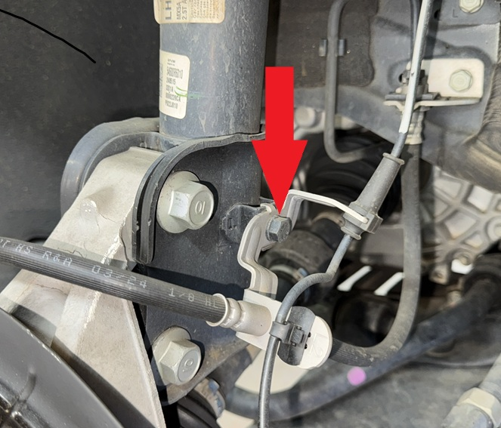
Step 4. Using 17mm wrench and 10mm wrench, remove sway bar link.
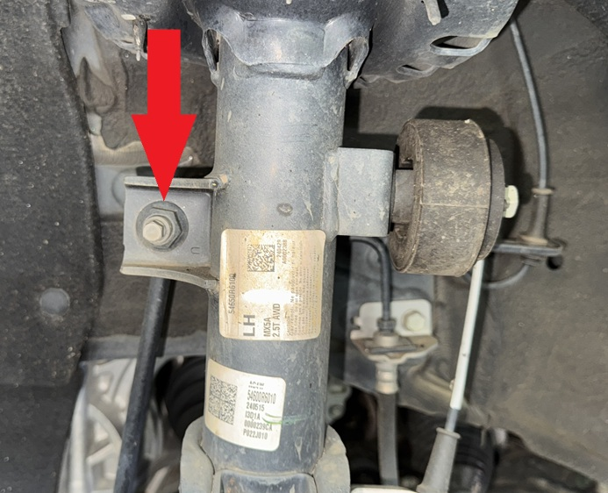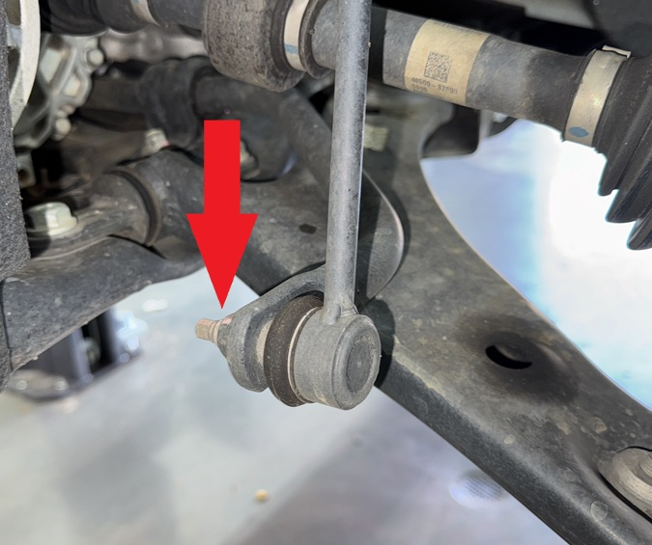
Step 5. Remove nuts connecting strut to knuckle. Tap bolts out with a hammer.
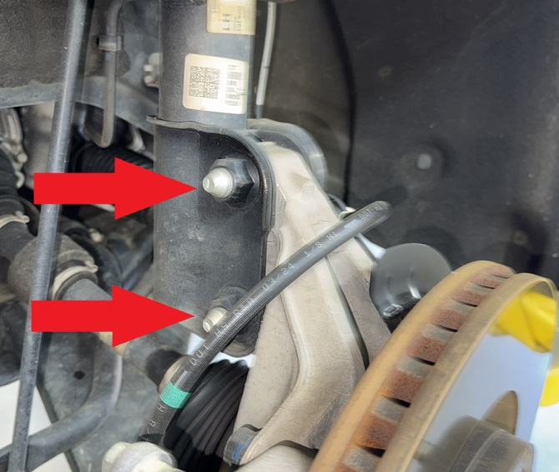
NOTE: Do not allow the hub to fall loose, as the axle may come out of the inner CV joint.
Step 6. Support knuckle with floor jack or screw jack.
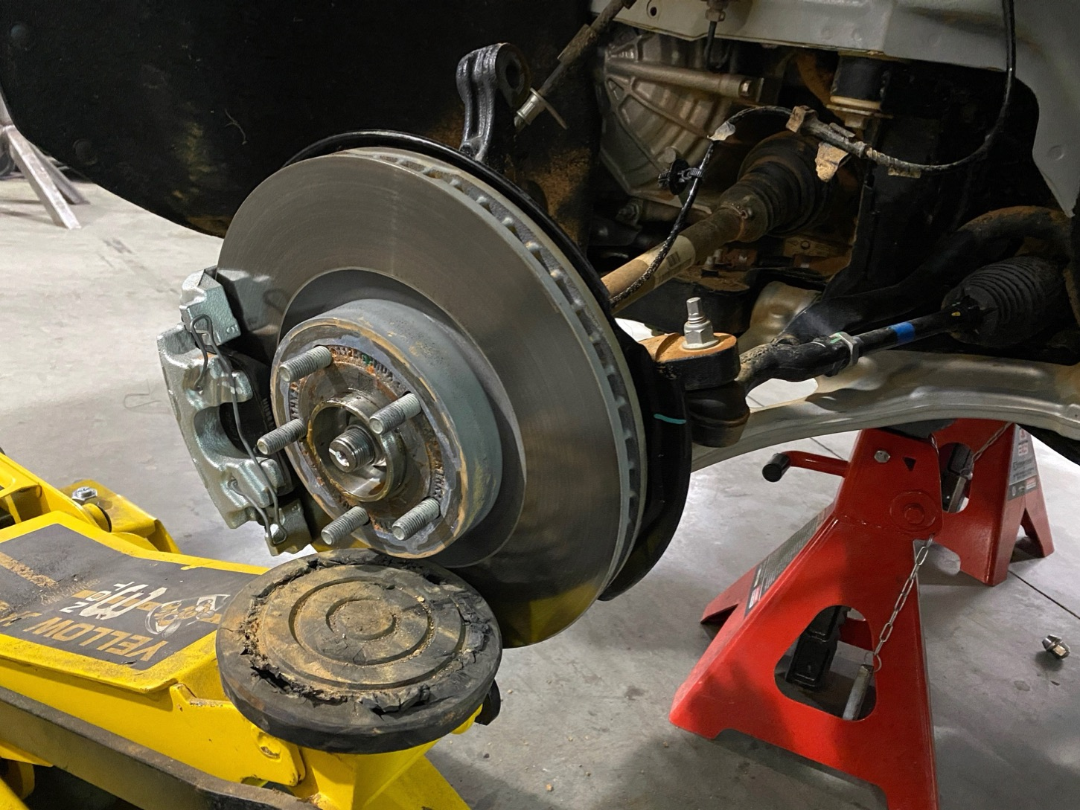
Step 7. Remove 14mm nuts at the top of the strut connecting strut to strut tower. Remove strut. Save hardware for reinstallation.
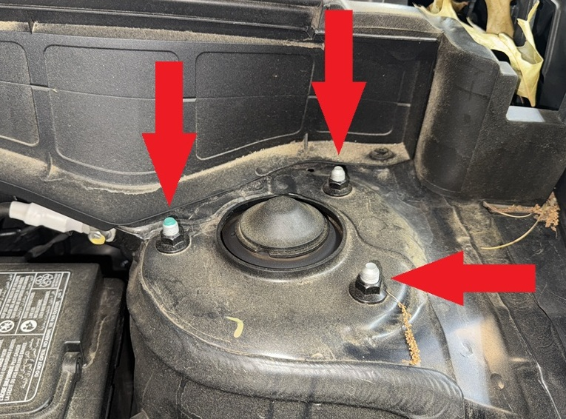
Step 8. Attach lift spacers onto strut using supplied M10 nuts as shown.
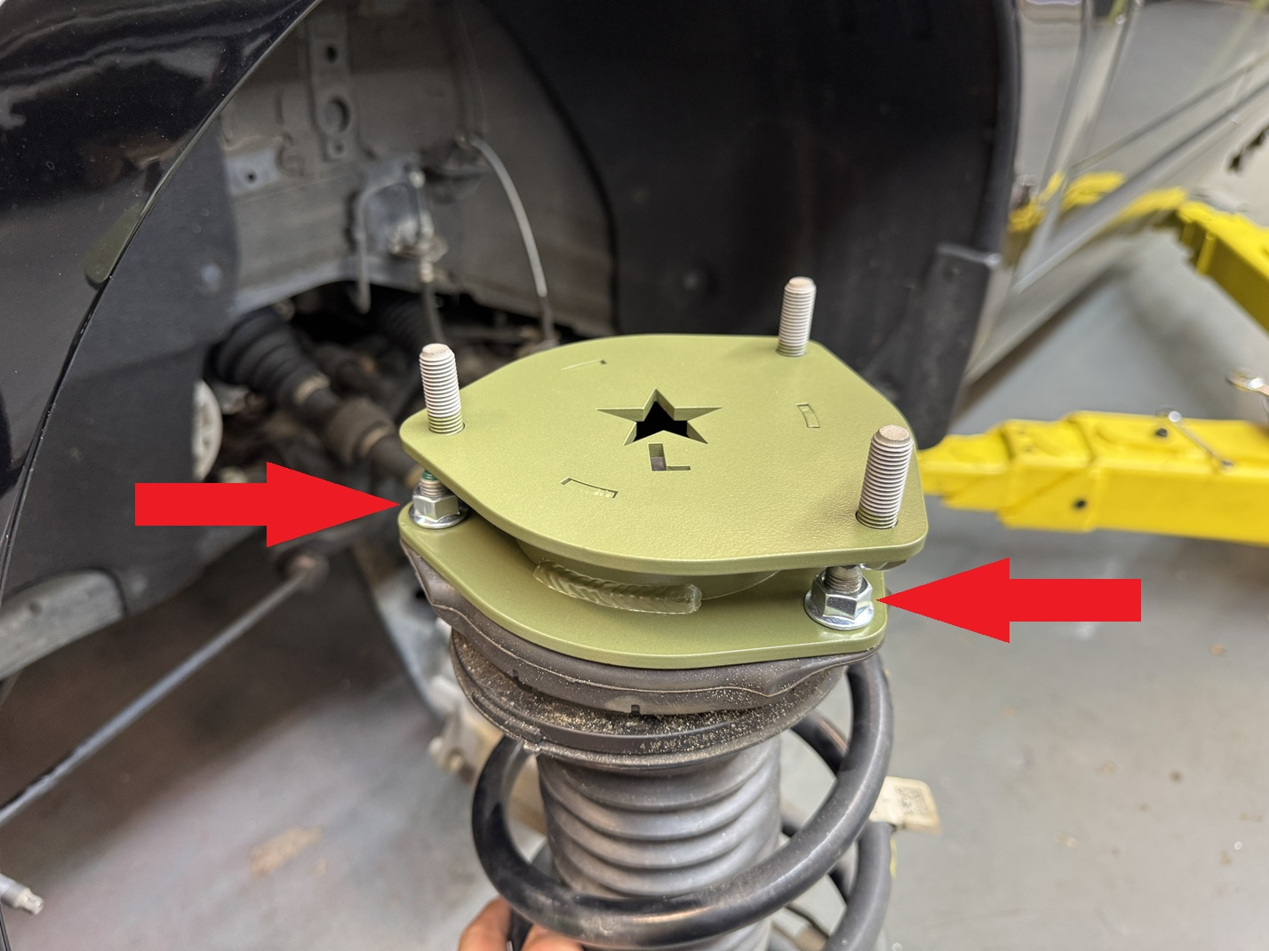
Step 9. Reinstall strut into shock tower with spacer attached, using original hardware.
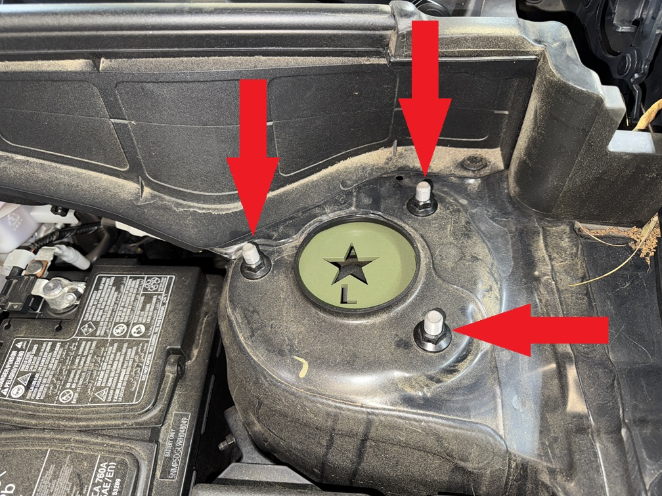
Step 10. Install lower bolts connecting strut to knuckle.
Step 11. Install offset camber adjustment bolt in place of upper strut bolt. (see separate instructions on last page.)
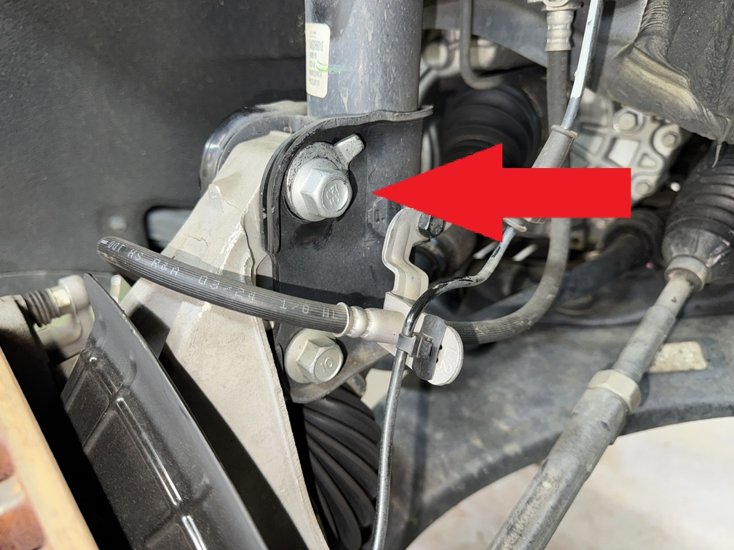
Step 12. Reinstall bolt holding brake and ABS lines.
Step 13. Repeat installation process for passenger side.
Step 14. Install shorter sway bar end links included with the kit. (links will not line up until both sides are lifted)
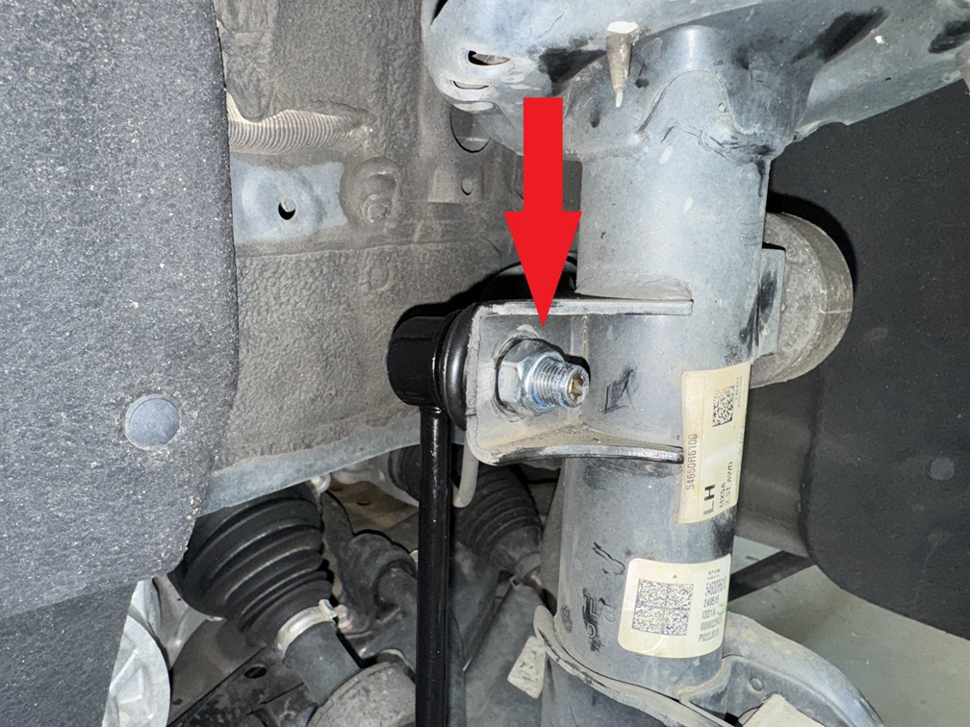
Step 15. Double check all bolts.

Rear installation:
Step 1. Lift vehicle and support with jack stands.
Step 2. Remove wheels.
Step 3. Starting on the driver side: Remove plastic clip holding felt fender liner to gain access to rear brake line mount.
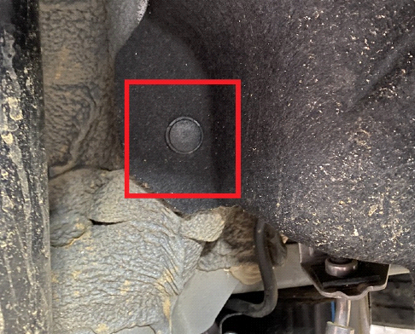
Step 4. Remove bolt holding brake hardline to body.
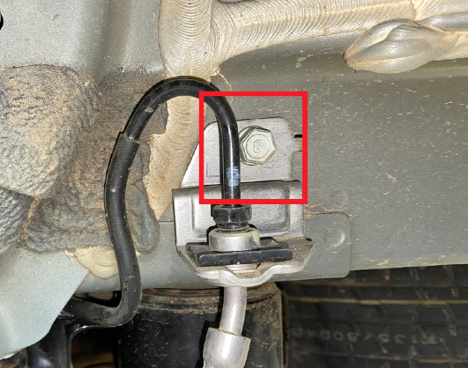
Step 5. Install brake line relocation bracket as shown. Carefully bend steel brake line so that it does not make contact with the subframe.
5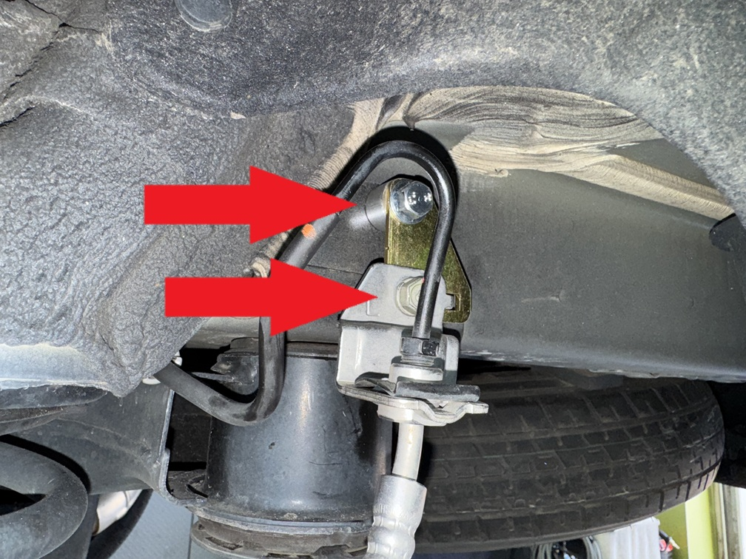
Step 6. Disconnect sway bar end link from lower control arm.
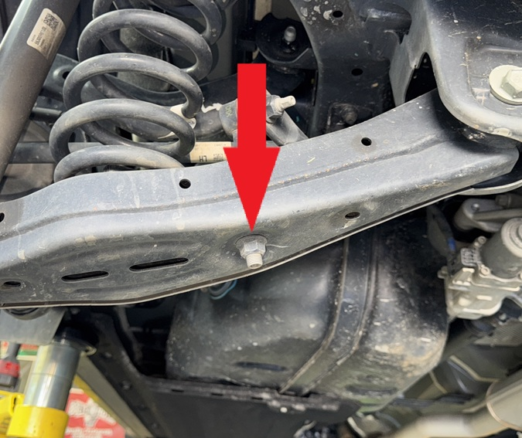
Step 7. Support lower control arm with floor jack or screw jack.
Step 8. Remove shock mounting bolt from lower control arm.
Step 9. Remove bolt holding lower control arm to wheel hub.
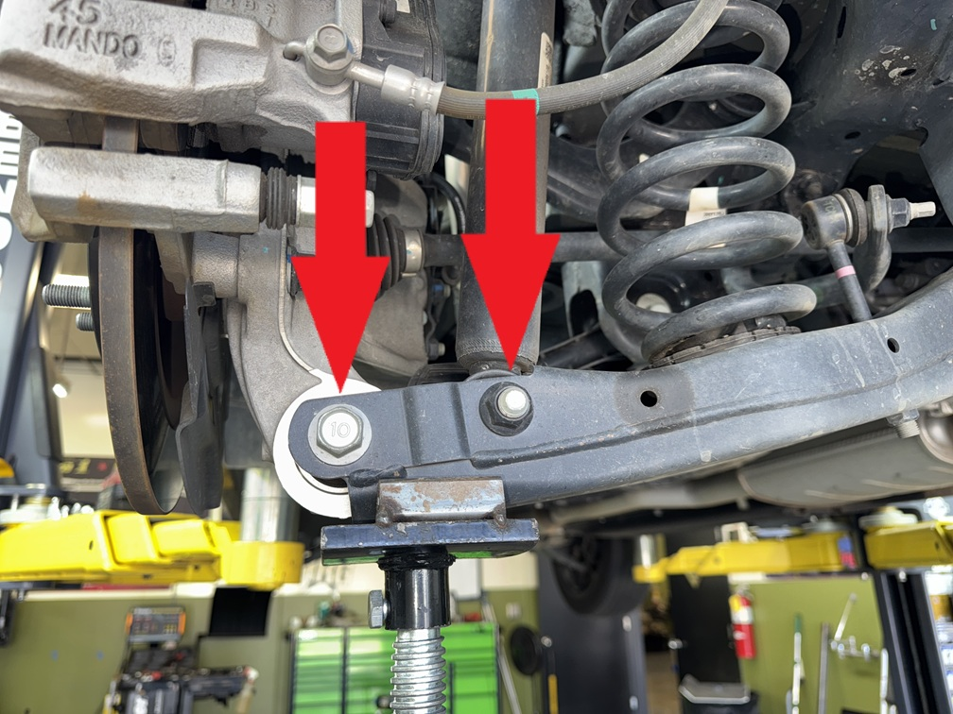
Step 10. Carefully release spring tension by lowering jack or screw jack.
Step 11. Remove spring and upper rubber isolator.
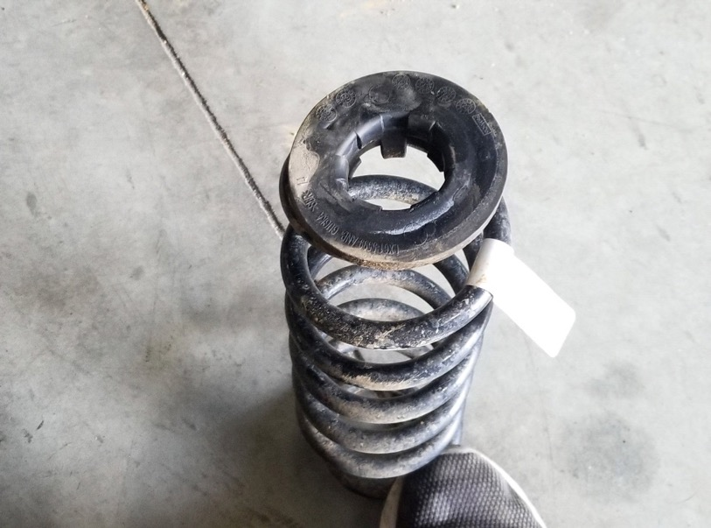
Step 12. Remove 2 bolts holding shock to body of vehicle.
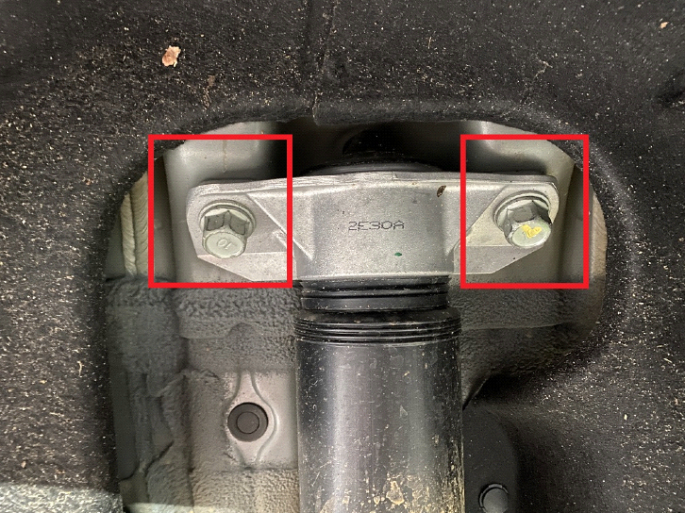
Step 13. Install rear shock relocation bracket as shown:
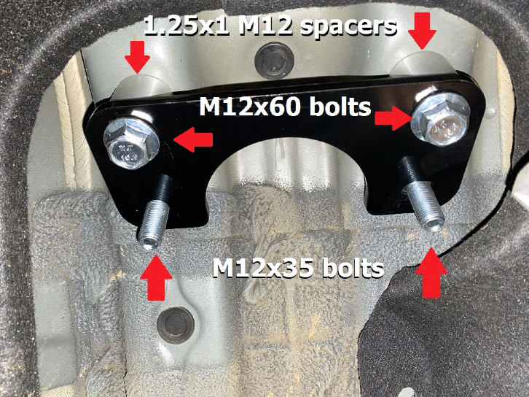
Step 14. Install rear shock absorber as shown:
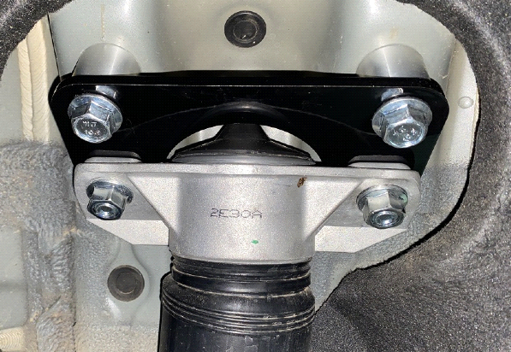
Step 15. Remove 2 bolts holding trailing arm to body.
Step 16. Place provided 1.25x1 M12 machined spacers between trailing arm and body.
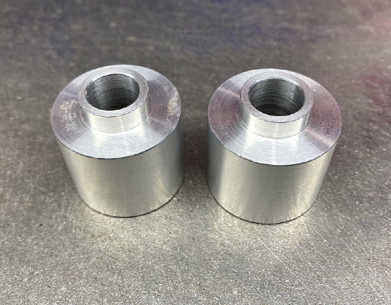
Step 17. Install provided M12x70 bolts to secure trailing arm.
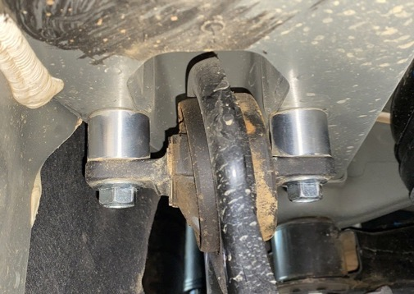
Step 18. Place rubber isolator over rear spring spacer.
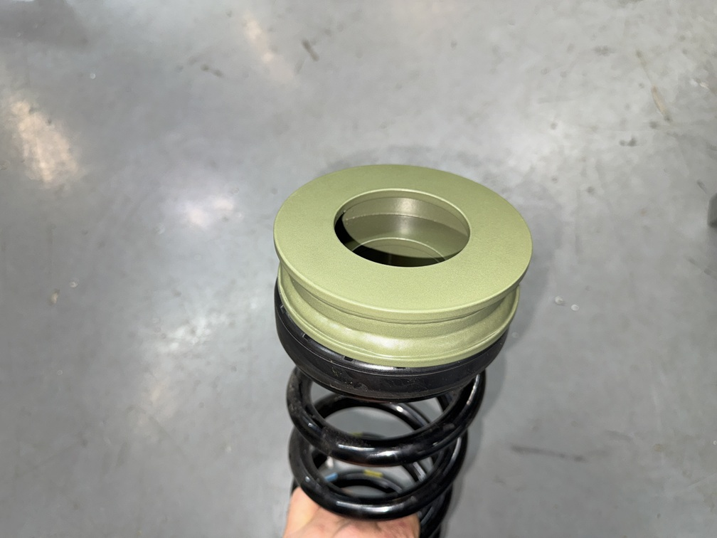
Step 19. Install spring and spacer.
Step 20. Using a jack, lift lower control arm until shock bolt holes line up.
Step 21. Reinstall bolt holding shock to lower control arm.
Step 22. Using a jack, lift lower control arm into position to line up bolt hole on wheel hub.
Step 23. Reinstall bolt holding lower control arm to wheel hub.
Step 24. Reinstall sway bar end link.
Step 25. With the lower control arm lifted up (simulating the position it will be in with the car on the ground) tighten all bolts.
Note: Tightening the bolts with the arms in the air may cause premature bushing failure.
Step 26. Repeat steps installation process for passenger side.
Step 27. Reinstall wheels and lower vehicle.
*VEHICLE MAY APPEAR TO SIT EXTREMELY HIGH AT FIRST. ROLL VEHICLE FORWARD AND BACK TO SETTLE SUSPENSION!
Step 28. Get a professional 4 wheel alignment.
Step 29. Find some trails!

Note: Installing a lift kit will change the suspension geometry and will require a 4 wheel alignment.
Warning: Failure to follow the procedures in these installation instructions may result in unsafe handling characteristics, damage to vehicle, or loss of control.
For tech support, please call 1-844- HRG LIFT (474-5438) from 8-4:30 PM EST Mon-Thu 8-3:30 PM Fri or email us 24/7 at support@hrgoffroad.com.
This product is intended for off-road use only!!
Copyright HRG Offroad 2026

Checklist:
__ SAN2225F-1.5 5401 (2)
__ SAN2225R-1.25 5402 (2)
__ SAN2225-RBLB-1 (1 pack of 2)
__ SAN2225-RSE (1 pack of 2)
__ M12x70 (1 pack of 4)
__ SAN2225-Trailing arm spacers(1 pack of 4)
__ 0.25x2.75 M16 pac man spacers (4)
__ sticker
__ Instruction Card

