
2019-2024 Subaru Forester and Forester Wilderness 4" (102mm) lift kit installation guide
Professional installation is recommended
IMPORTANT!
Lifting and modifying the suspension on your vehicle may result in drive line vibrations, damaged bushings, erratic handling characteristics, and shortened suspension component life. HRG Offroad recommends the following:
-Checking and/or replacing worn drive axles with new parts, not remanufactured.
-Checking and/or replacing all worn factory rubber bushings with urethane bushings, such as Prothane.
-Checking and/or replacing worn shock absorbers and bump stops.
-Performing a 4 wheel alignment after working on suspension components.
Lift kits may not be legal for use on public highways in your area. Please check local laws before installing!!
WARNING!
Lifted vehicles are more prone to rolling over.
Some HRG Offroad products are designed to improve off-road capabilities. Modifying the suspension of your vehicle may result in handling characteristics that are different from a factory equipped vehicle. Extreme care must be used to prevent a rollover or loss of control. Always operate your modified vehicle at a reduced speed to ensure your ability to maintain control under all driving conditions. Driving your vehicle in an unsafe manner may result in serious injury or death. HRG Offroad lift kits are designed and tested to work together. HRG Offroad does not recommend combining this lift kit with any other type of suspension or body lift. Always wear your seat belt.
Recommended tire/wheel sizes:
Stock: 225/60/17 (27.6”)
ALL 17” SIZES ASSUME STOCK WHEELS!
235/60/17 (28.1")
225/65/17 (28.5”)
235/65/17 (29”)
245/65/17 (29.5”)
EXTREME SIZE: 235/70/17 (30”) WILL require fender/pinch weld trimming
Stock: 225/55/18 (27.7”)
ALL 18” SIZES ASSUME STOCK WHEELS!
235/55/18 (28.2)
245/55/18 (28.6)
245/60/18 (29.5”)
EXTREME SIZE: 235/65/18 (30”) WILL require fender/pinch weld trimming
Be sure to check fitment prior to installation! These sizes are only suggestions. HRG is not responsible for improperly fitted wheels/tires!

Included in the kit:
2 3.0” (76mm) offset lift spacers (front)
2 3.0" (76mm) lift spacers (rear)
6 M10 nuts (front)
4 M10 nuts (rear)
2 0.25” (6.4mm) lift spacers (front)
1 2 inch steering shaft extension
3 M6 hex head set screws
2 front brake line relocation brackets
2 rear brake line relocation brackets
4 M8x16 bolts (brake line brackets)
4 M8 nuts (brake line brackets)
2 2” (51mm) engine cradle spacers
4 M12x160 bolts (engine cradle)
2 2” (51mm) front lower arm spacers
2 M14x160 bolts (lower arm spacers)
4 M14x70 bolts (lower arm spacers)
2 “dog bone” brackets
1 “Z” bracket (vacuum hose mount)
1 M6x16 bolt (vacuum hose mount)
1 M6 nut (vacuum hose mount)
6 1x2 M10 spacers (transmission crossmember)
6 M10x70 bolts (transmission crossmember)
2 1x2 M10 spacers (carrier bearing)
2 M10x90 bolts (carrier bearing)
4 0.75x1 M8 spacers (exhaust heat shield)
4 M8x40 bolts (exhaust heat shield)
2 rear sway bar relocation brackets
4 M8x16 bolts (rear sway bar relocation brackets)
4 M8 nuts (rear sway bar relocation brackets)
4 2.75x2 M14 spacers (rear subframe)
4 M14x200 bolts (rear subframe)
4 1x2 M10 spacers (rear subframe braces)
4 M10x70 bolts (rear subframe braces)
Tools required:
Floor jack, lug wrench, metric socket set up to 21mm, metric wrench set up to 19mm, panel puller, hex key set, common pliers, pipe wrench, plastic cutting tool, pry bar, torque wrench.
Approximate installation time: 4-8 hours
Skill level: Moderate
Front installation:
Step 1. Secure steering wheel with seat belt to prevent rotation.
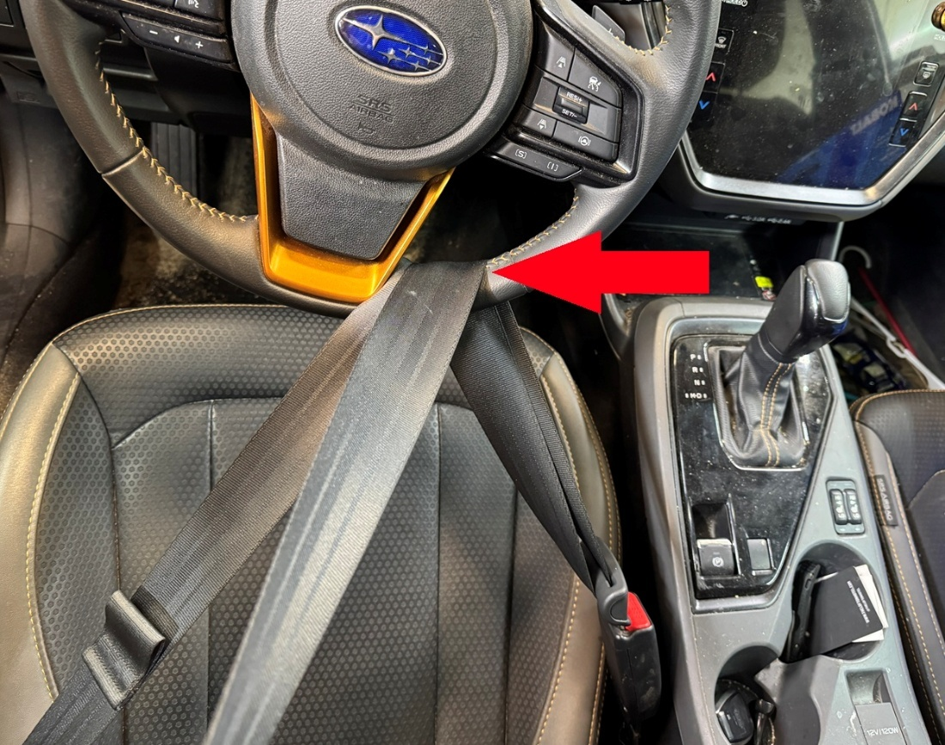
Step 2. Remove bolt holding vacuum line to firewall (see photo)
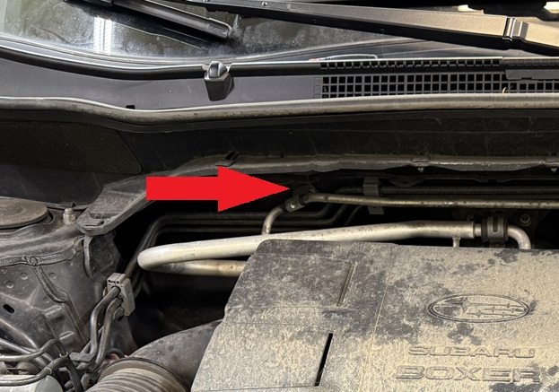
Install vacuum line relocation bracket as shown:
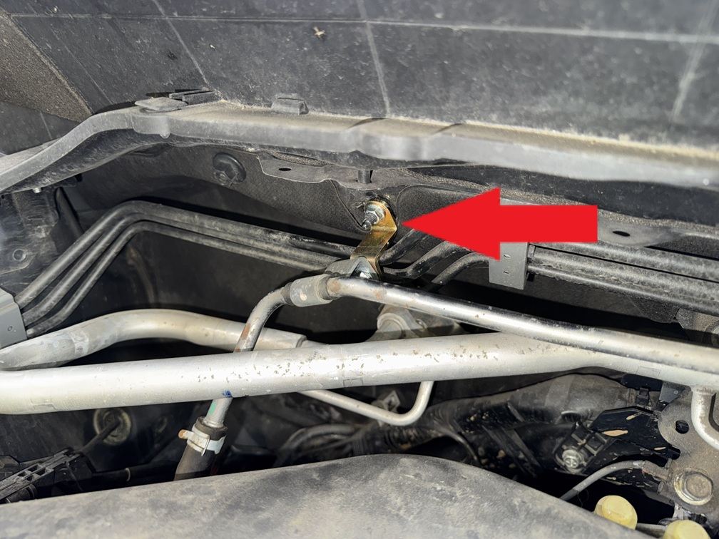
Remove plastic engine cover
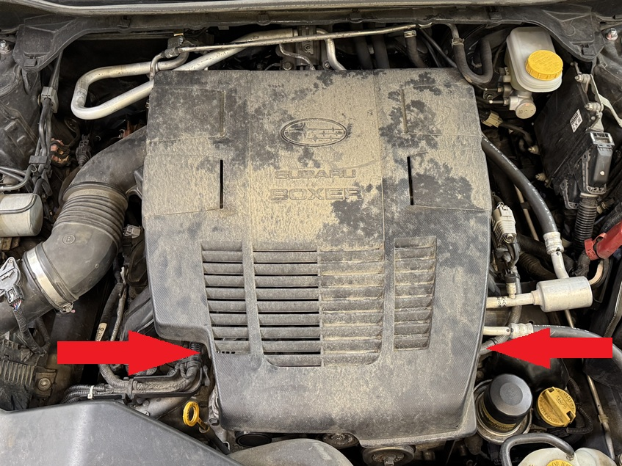
Remove air intake.
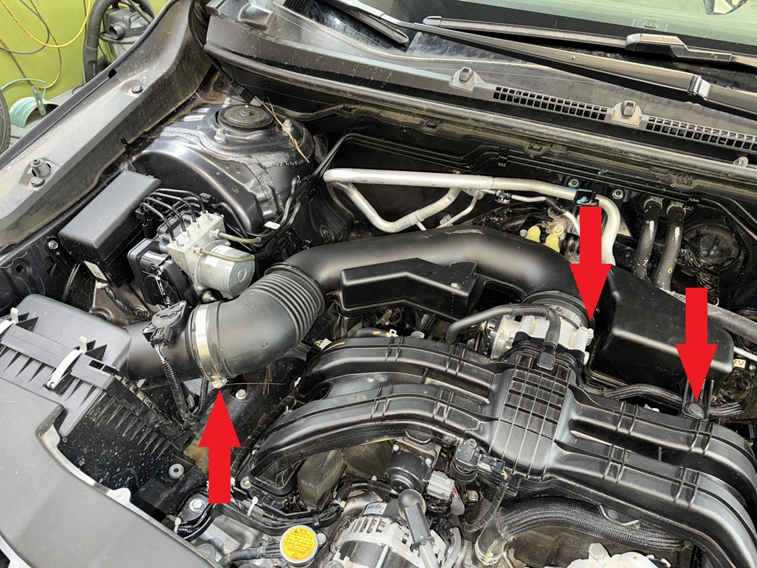
Step 3. Remove bolt holding “dog bone” and remove bolts holding “dog bone” bracket to transmission case.
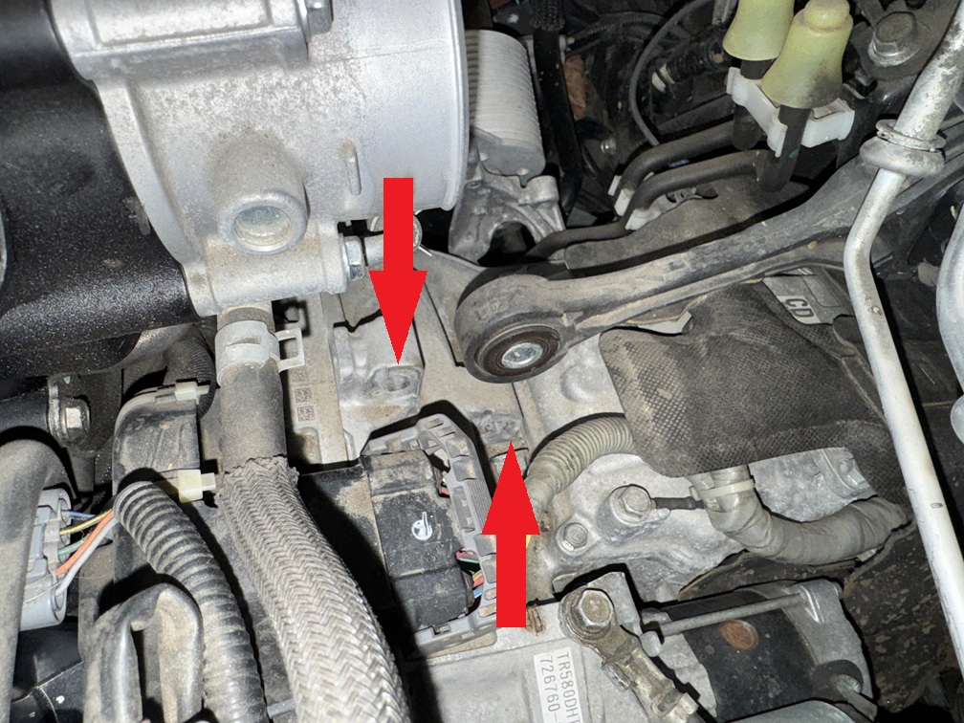
Step 4. Lift vehicle and support with jack stands.
Step 5. Remove wheels.
Step 6. Remove bolts and plastic clips on front splash shield
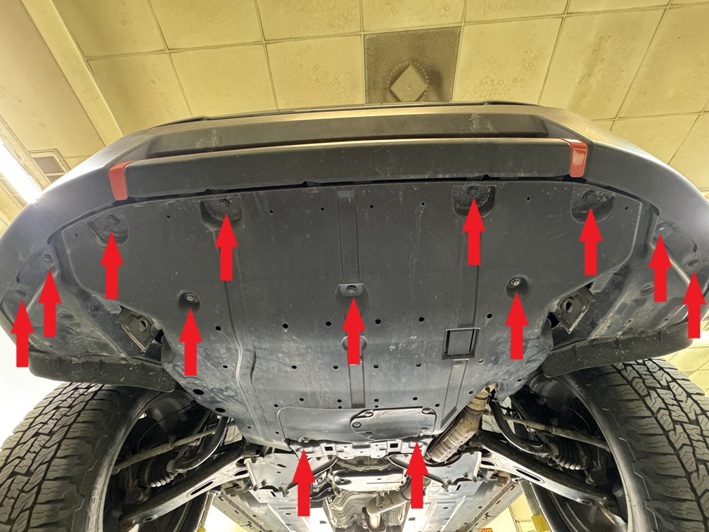
Step 3. Remove bolt holding steering coupler to steering rack.
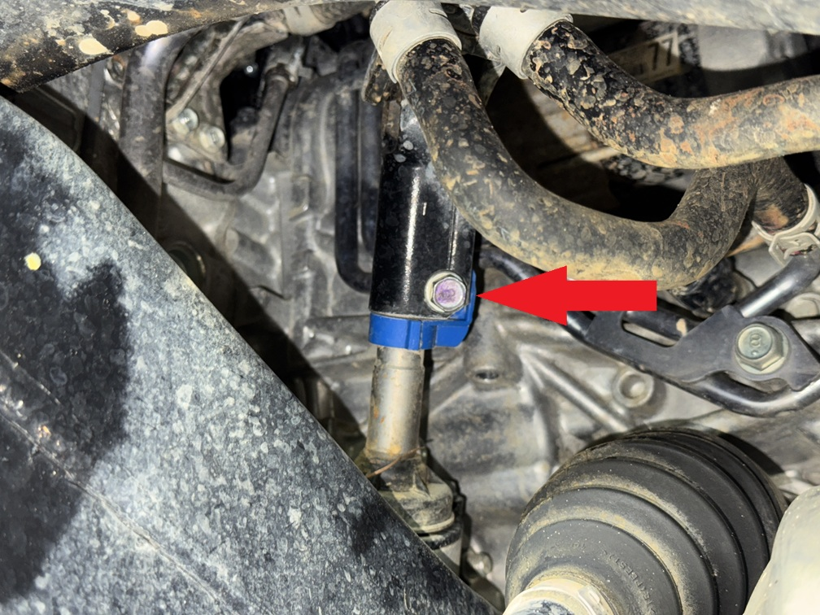
Step 4. Remove bolt holding ground wire to exhaust manifold. Bend mounting tab as shown. Wire will be reattached later.
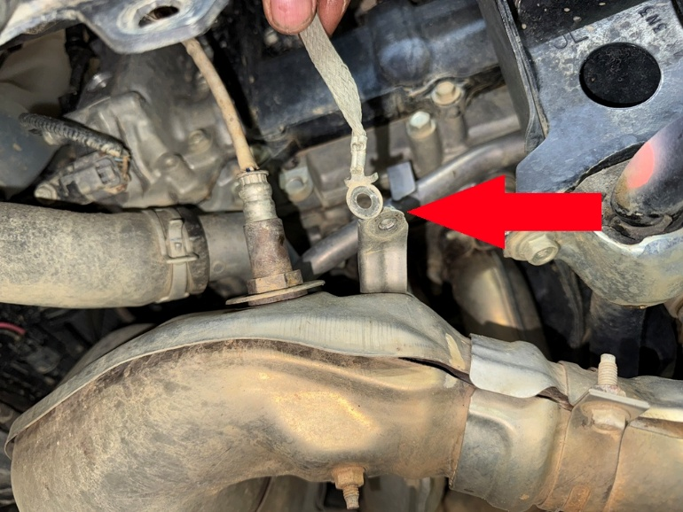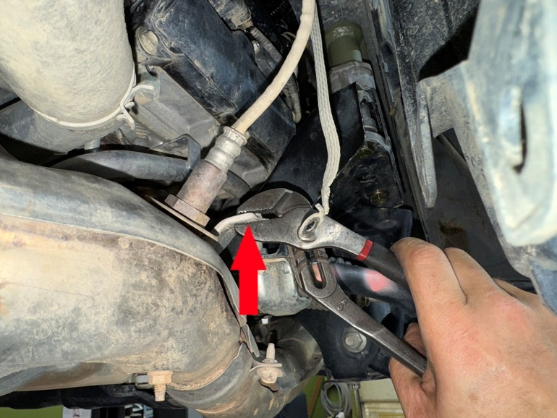
Step 5. Support engine with floor jack or screw jack.
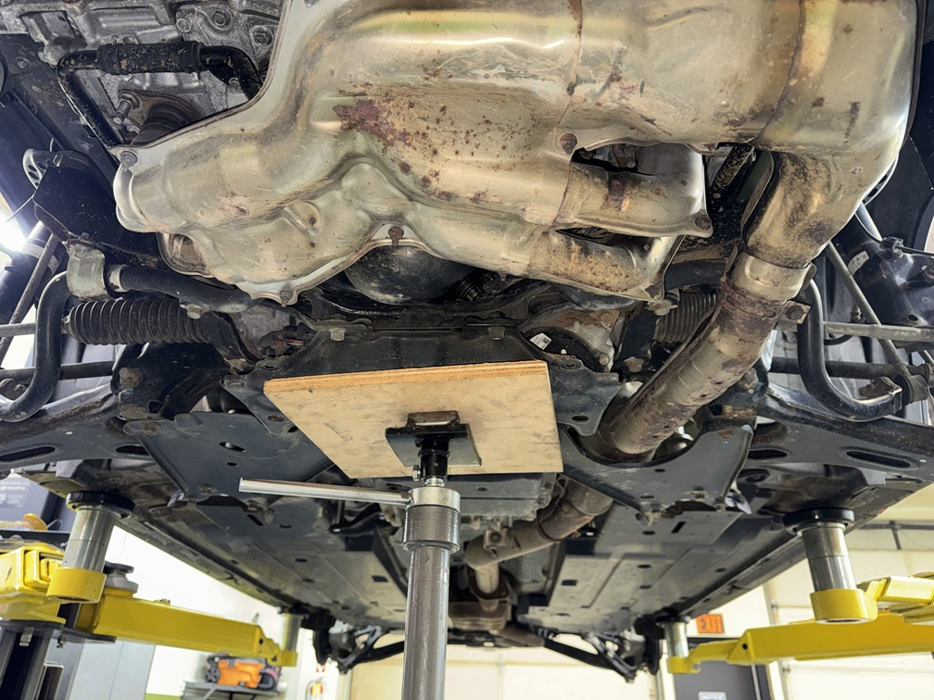
Step 6. Locate and remove bolts and nuts holding the front lower control arm mounts and support brackets. (see photo)
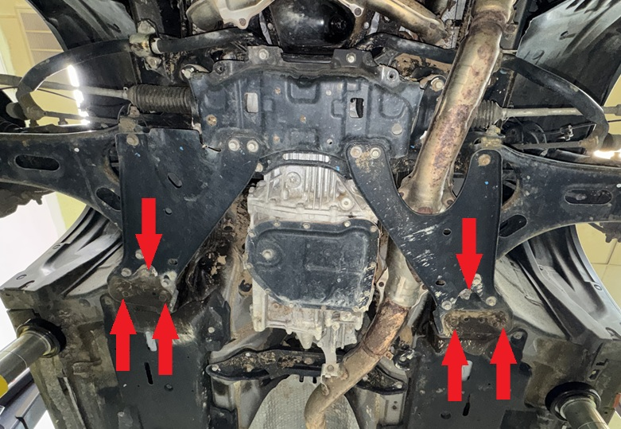
Step 7. Locate and remove bolts holding the engine cradle to the frame rail ONE AT A TIME. And replace them with the M12x160 bolts as you go. Installing the new bolts will keep everything aligned while lowering the engine cradle.
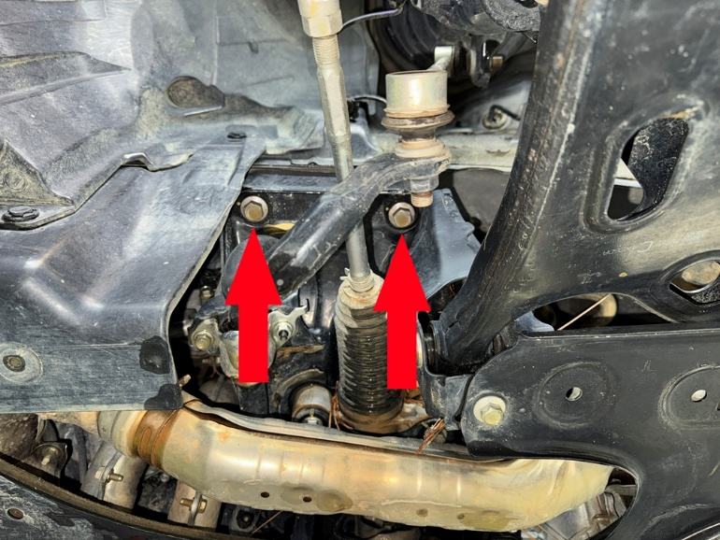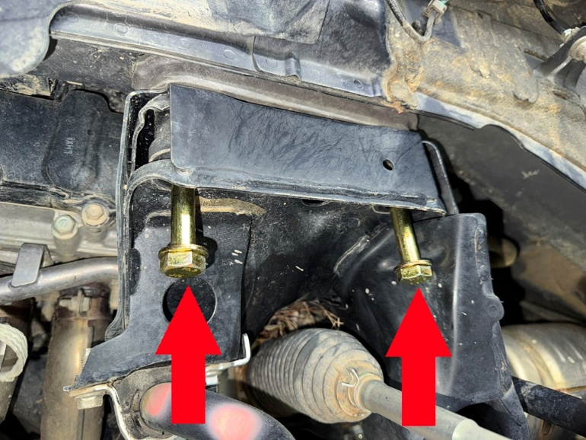
Locate the 6 transmission crossmember bolts. Remove these bolts and temporarily install the new M10x70 bolts included in the kit.
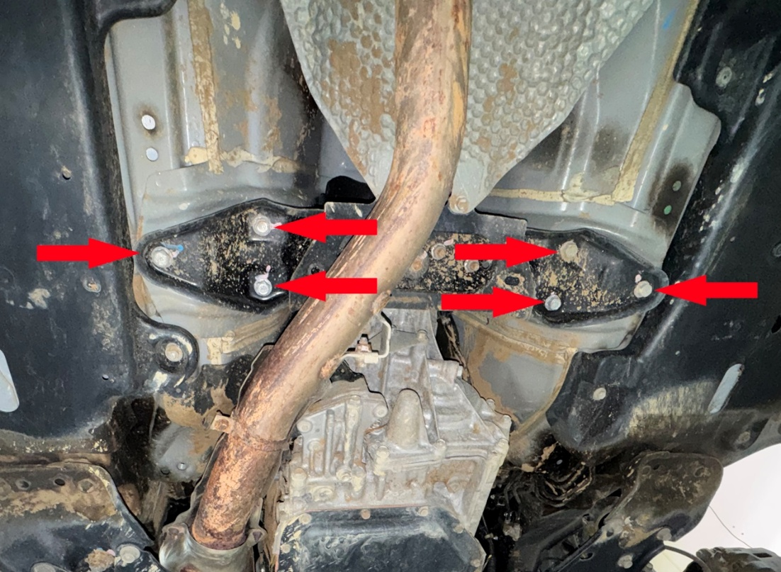
Step 8. Carefully lower engine/subframe just over 2 inches. Loosen engine cradle bolts more if necessary. Steering coupler will disconnect during this step.
Step 9. Remove plastic clip from steering shaft. DO NOT TURN THE WHEELS UNTIL THE STEERING COUPLER IS RECONNECTED.
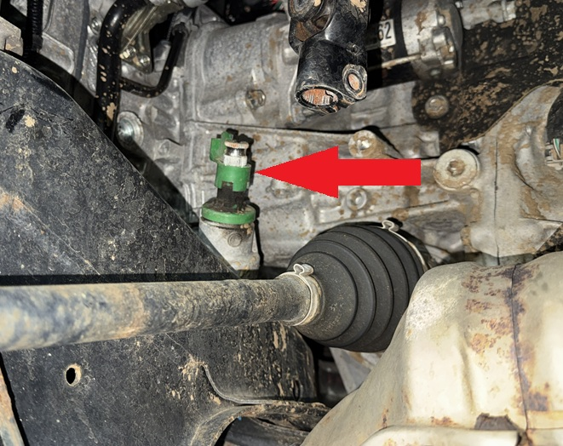
Step 10. Push steering shaft extension into coupler as shown:
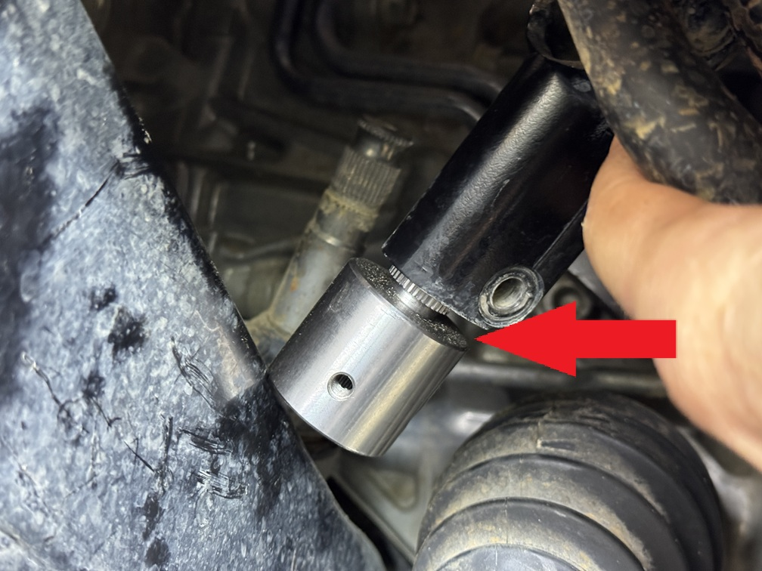
Step 11. Position steering extension on steering rack. Install set screws to prevent it from sliding off in the following steps. Do not tighten the pinch bolt on the steering coupler until the subframe drop is completed.
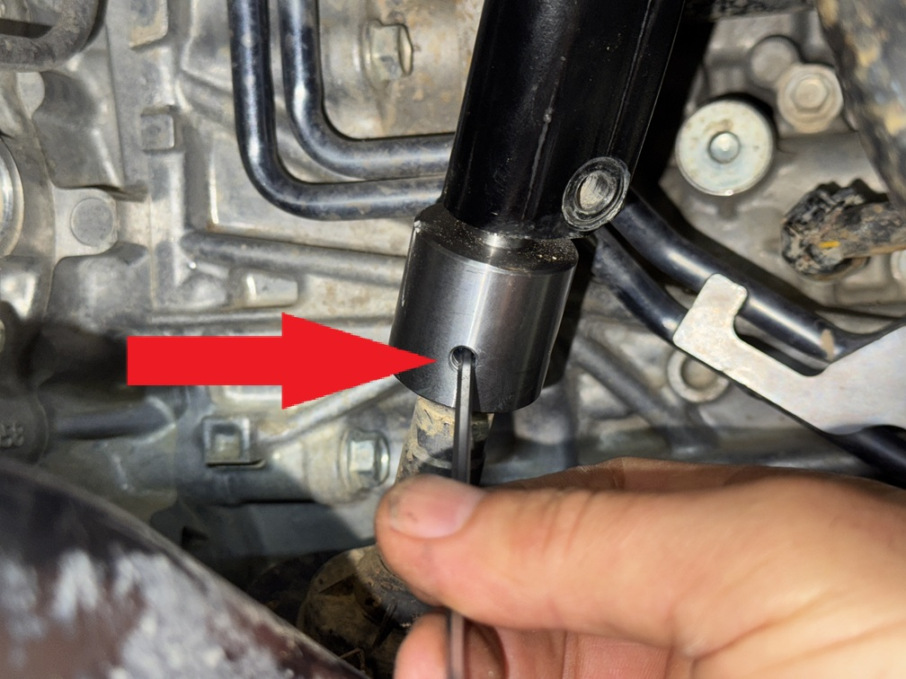
Step 12. Place engine cradle spacer between engine cradle and front frame rail as shown. Permanently install M12x160 bolts.
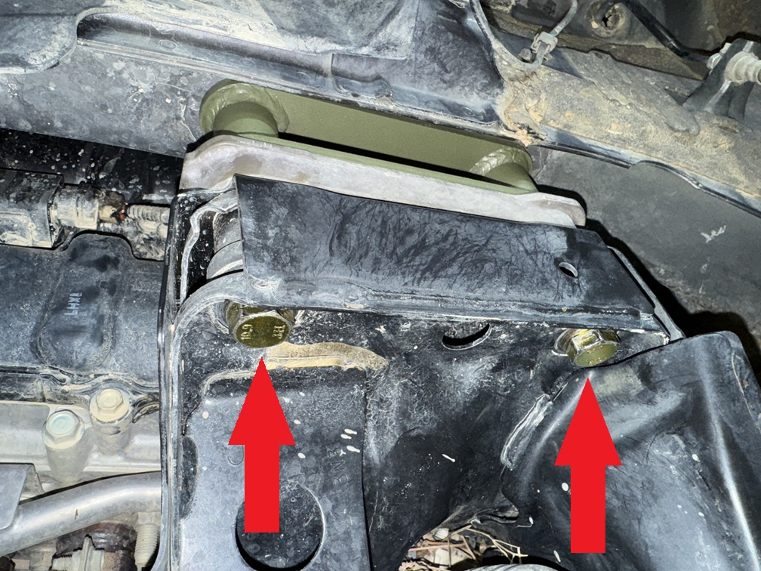
Step 13. Repeat process on passenger side.
Step 14. Push lower control arm down and off the stud as shown. Remove studs with a 15mm open end wrench.
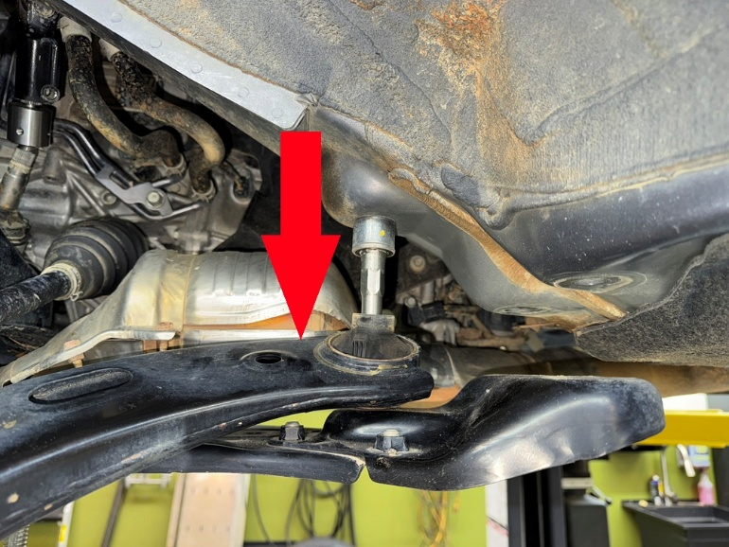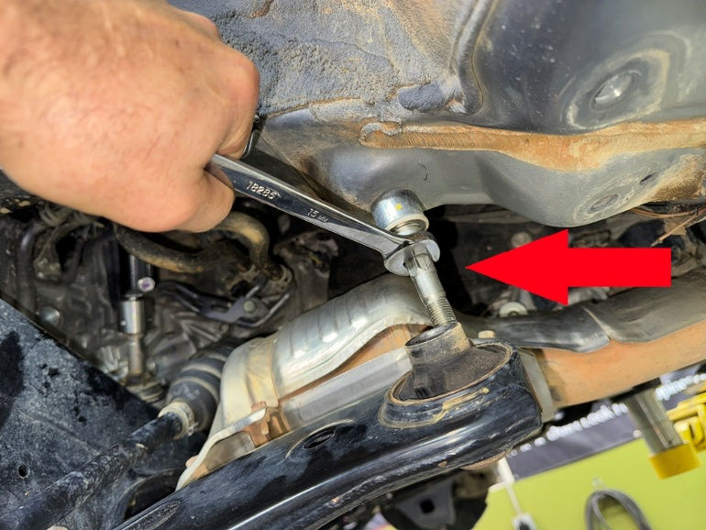
Step 15. Place front lower control arm spacer between front lower control arm and body as shown. Be sure to re-use the OEM spacer as shown in the photo.
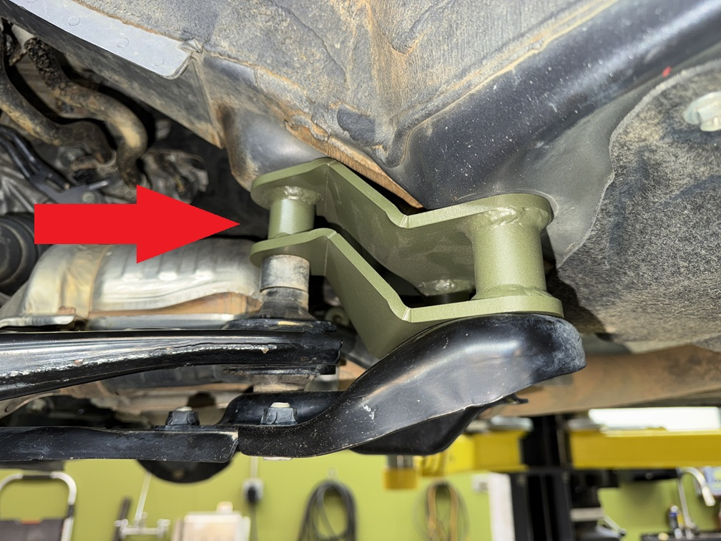
Step 16. Install M14x160 bolts through the lower control arm, lower control arm spacer, and into the body. Do not tighten bolt until all 3 bolts are threaded in.
Step 17. Install 2 M14x70 bolts into lower control arm bracket, through spacer, and into the body. Tighten all 3 bolts.
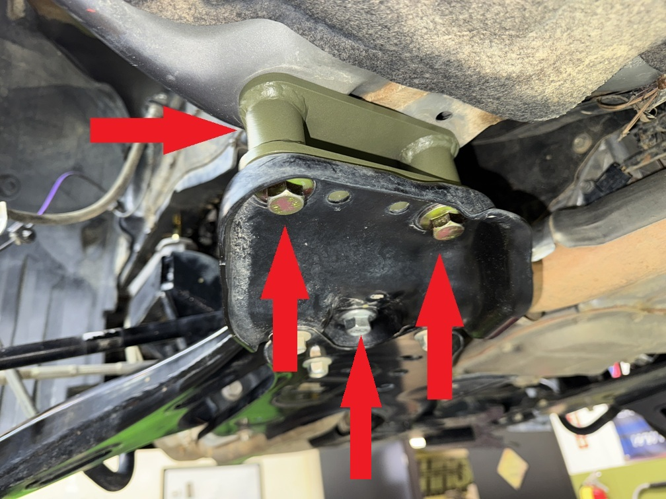
Step 18. Repeat for passenger side.
Step 19. Once all engine cradle and lower control arm mounting bolts are tight, install pinch bolt. Adjust coupler down onto the steering rack as far as possible BEFORE tightening the pinch bolt. NOTE: it is extremely important that the splines get maximum engagement on the steering rack! Failure to perform this step properly could result in loss of steering!
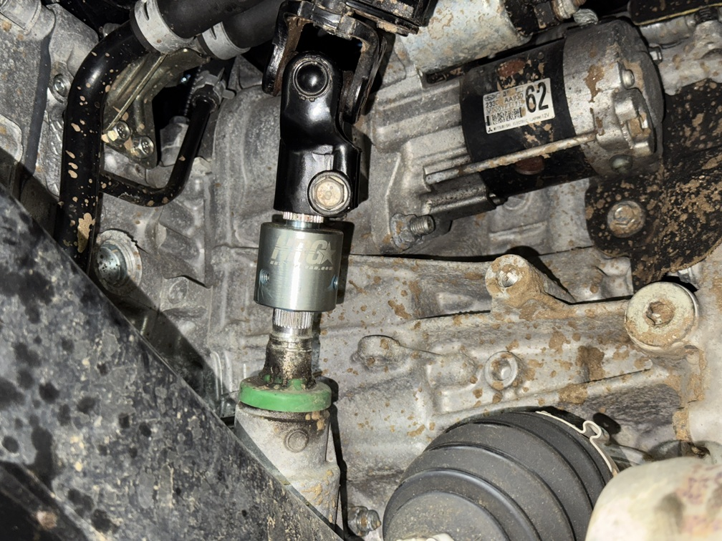
Step 20. Install all steering extension set screws with blue Loctite.
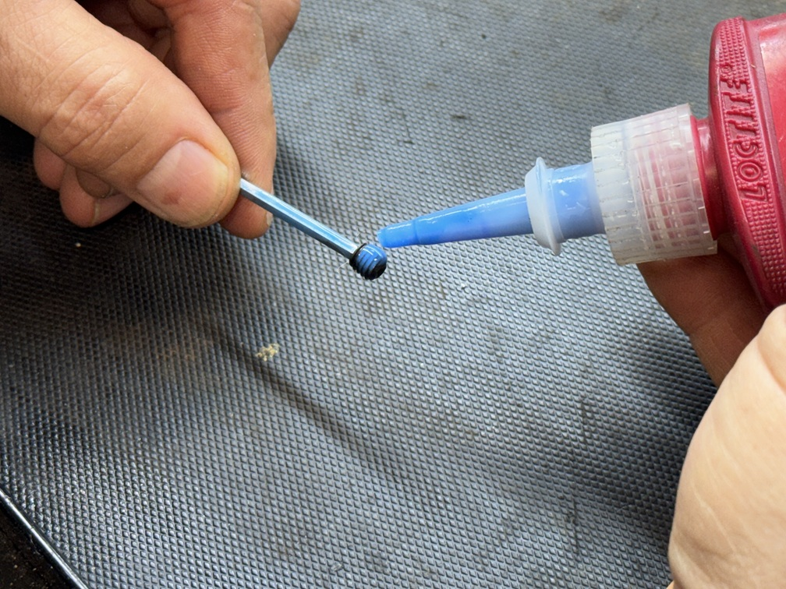
Step 21. Install “dog bone” relocation brackets as shown. Tighten all bolts.
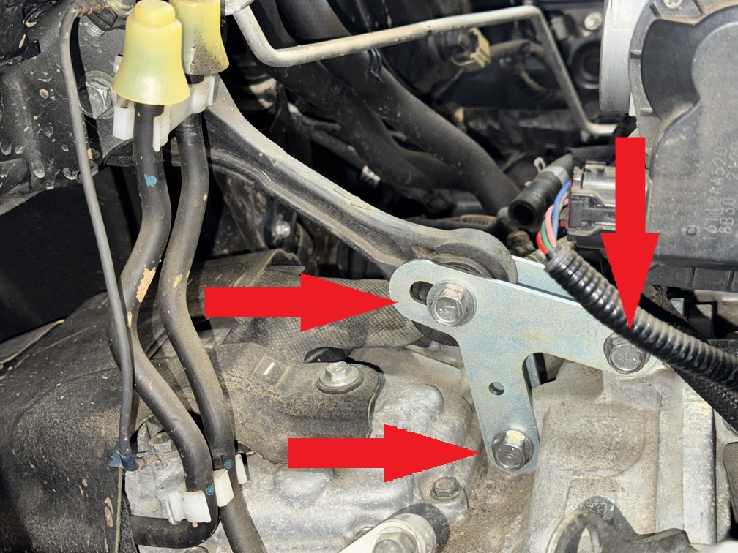
Step 22. Loosen upper “dog bone” bolt, then retighten it.
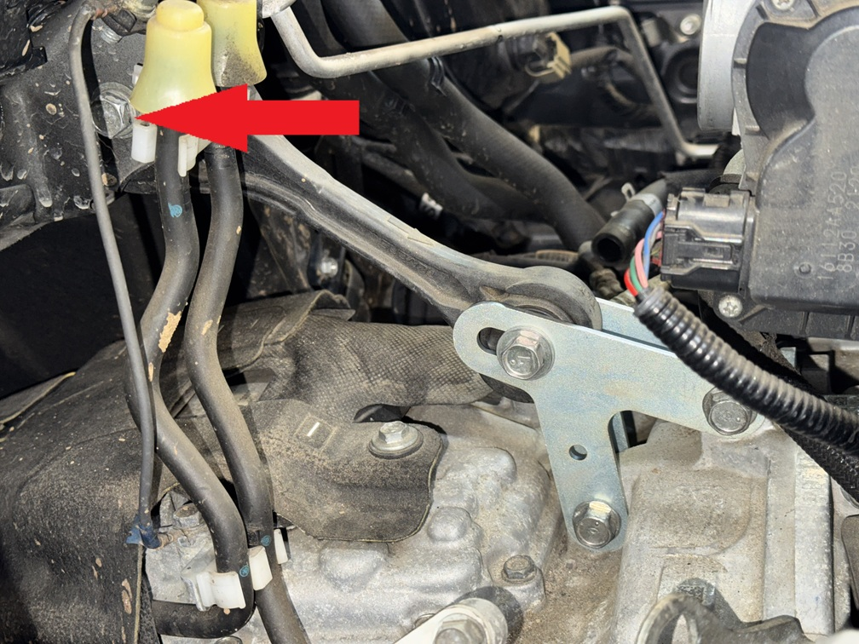

Step 24. Reinstall air intake. Do not forget to connect emissions hose.
Step 25. Reinstall ground wire on exhaust heat shield.
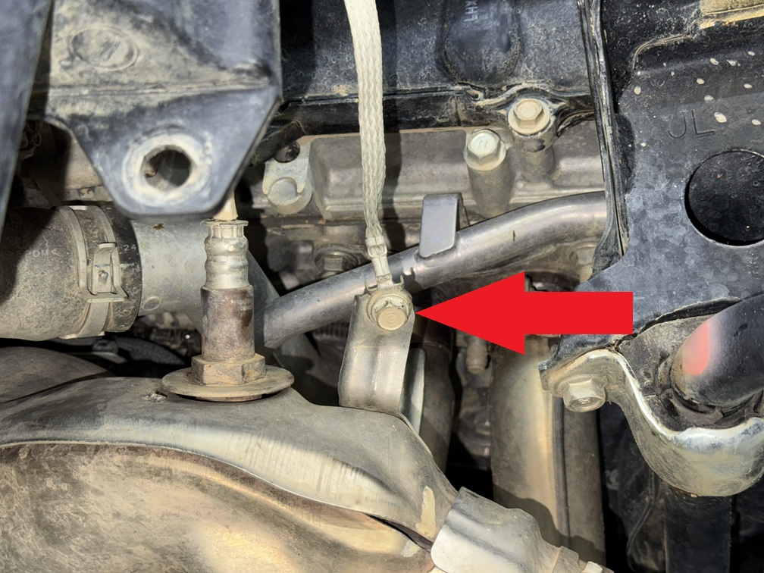
Reinstall lower plastic splash shield.
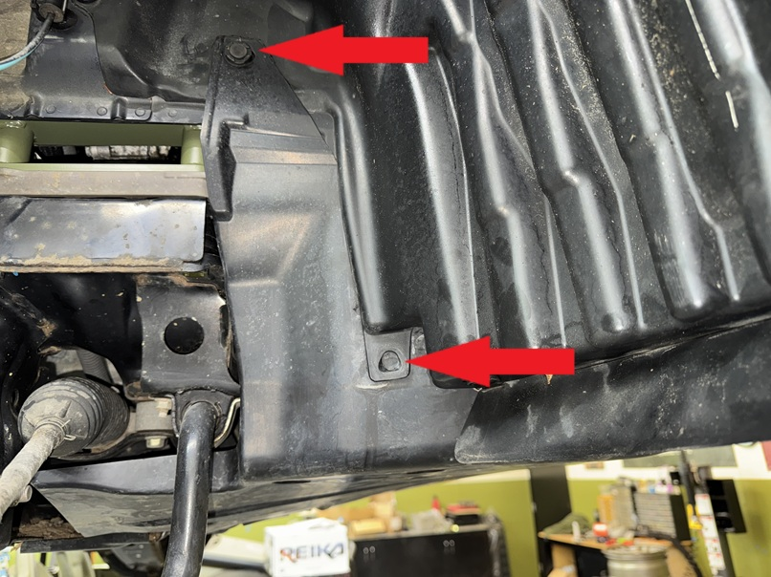
Step 26. Trim plastic splash shield as shown in photos below:
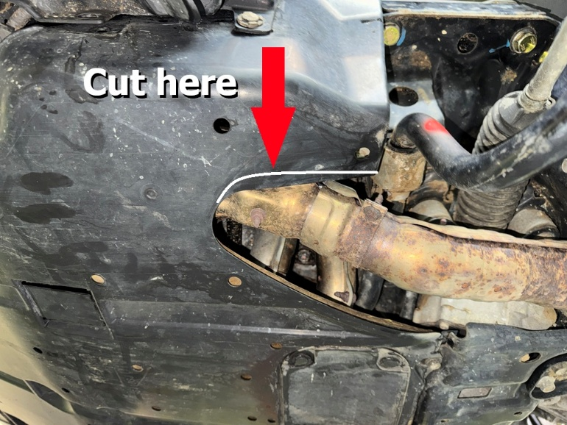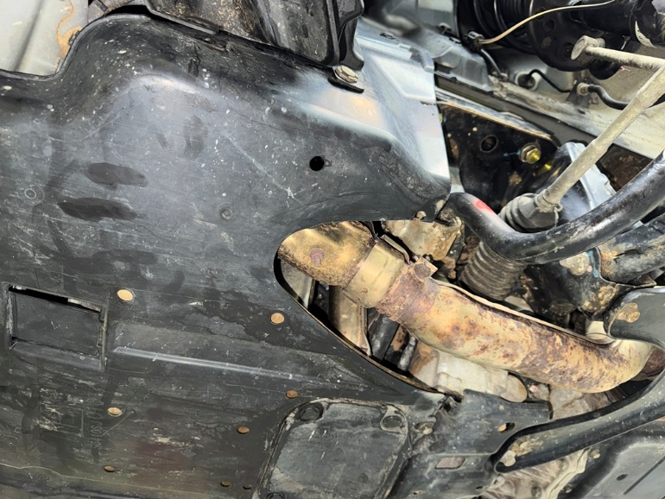
Step 27. Support transmission with floor jack or screw jack.
Step 29. Place 6 1x2 M10 spacers between transmission crossmember and body, install 6 M10x70 bolts as shown:
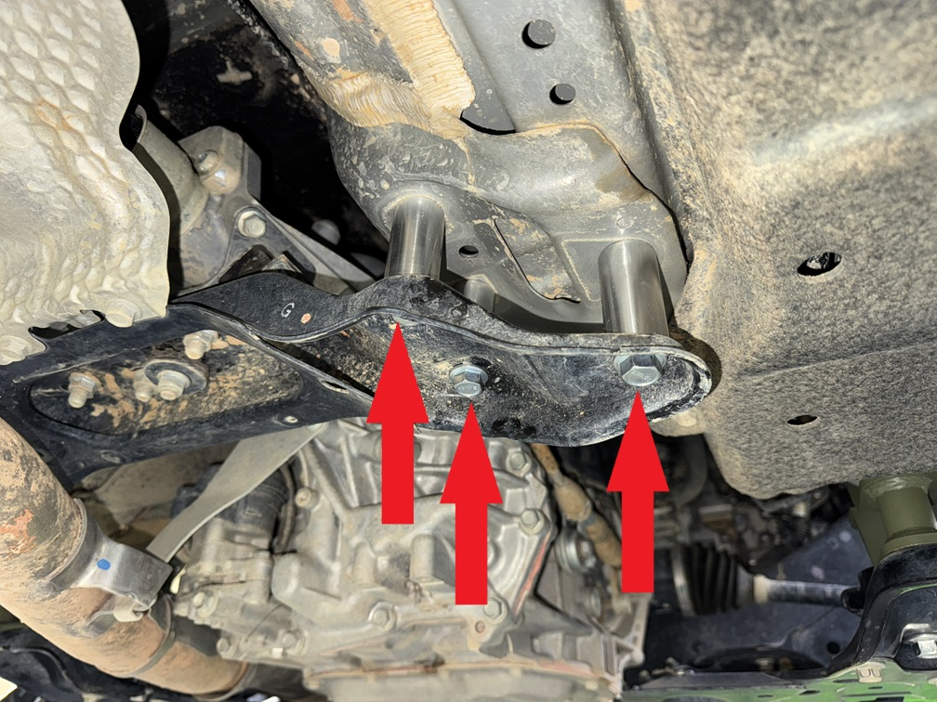
Step 30. Remove 2 bolts holding the drive shaft carrier bearing.
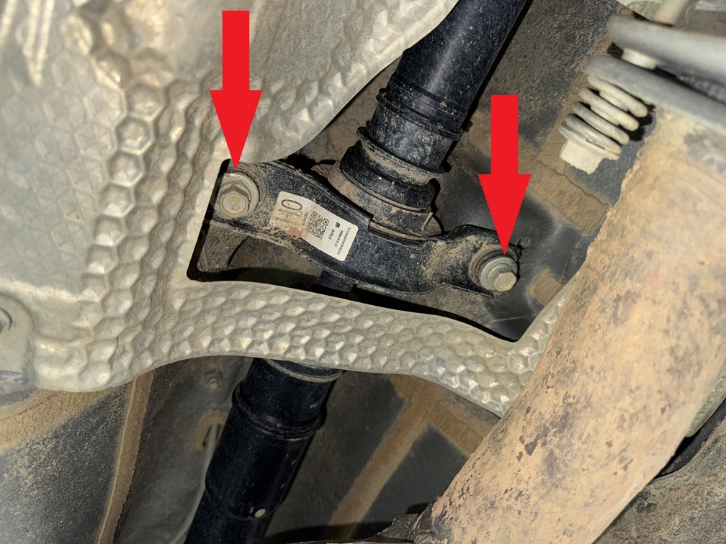
Step 31. Place 2 1x1 M10 spacers between carrier bearing and body, install 2 M10x90 bolts as shown:
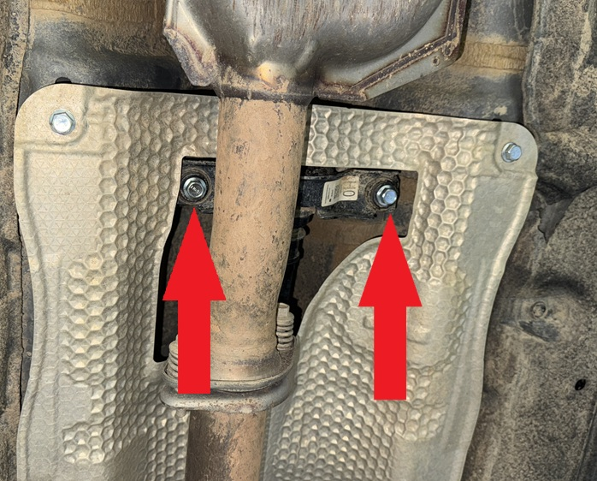
Step 32. Remove 4 bolts holding exhaust heat shield to body.
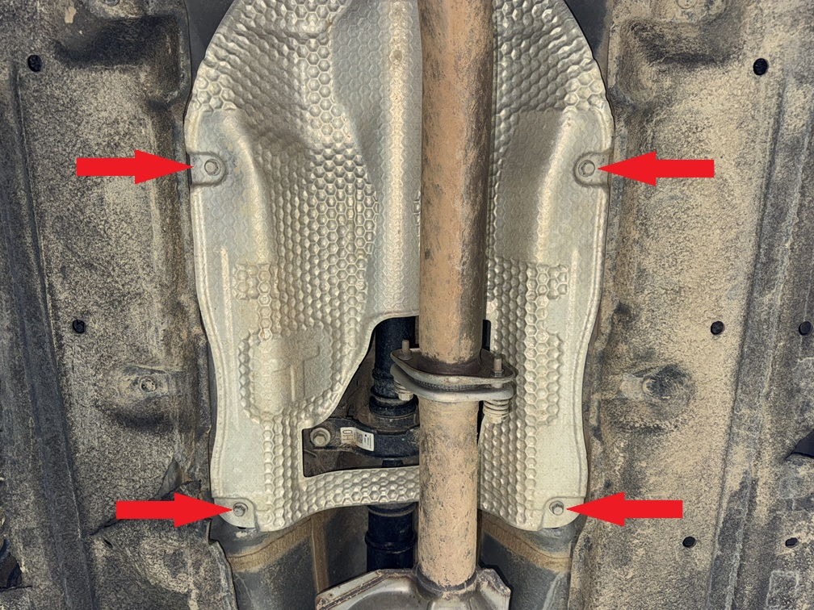
Step 33. Place 4 0.75x1 M8 spacers between heat shield and body, install 4 M8x40 bolts.
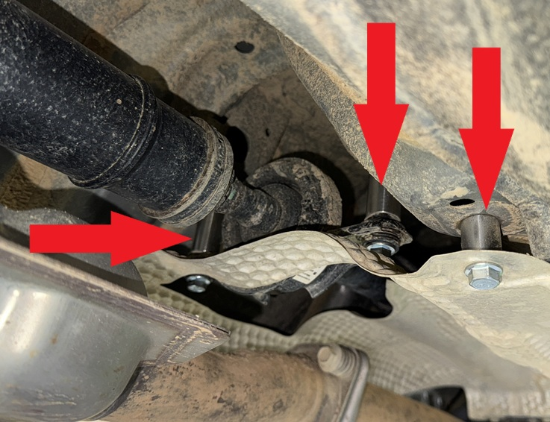
Remove bolts holding the brake line, the nut holding the sway bar end link and un-clip ABS wiring from the driver side strut.
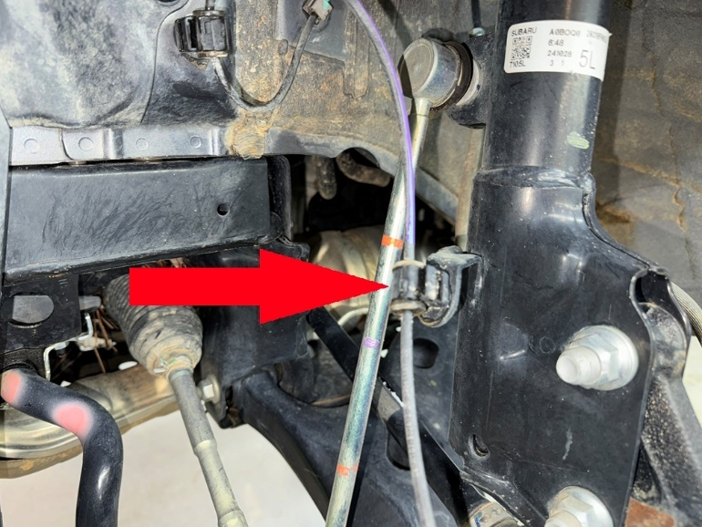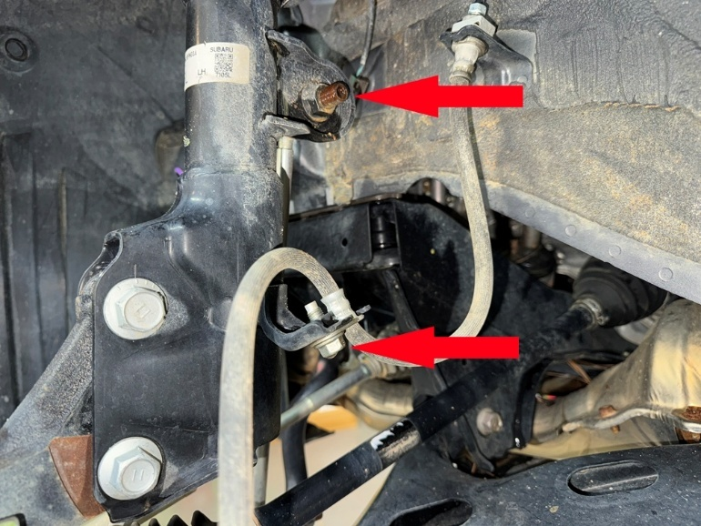
Step 35. Using a 19mm socket, remove 2 large nuts on bottom of strut, and tap bolts out with a heavy hammer.
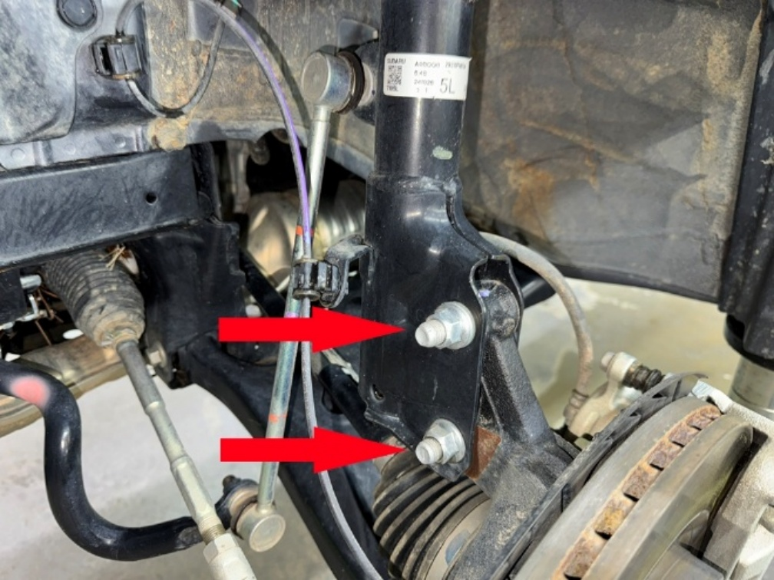
Step 36. Remove 3 M8 nuts from strut top to allow strut to drop out. (save hardware).
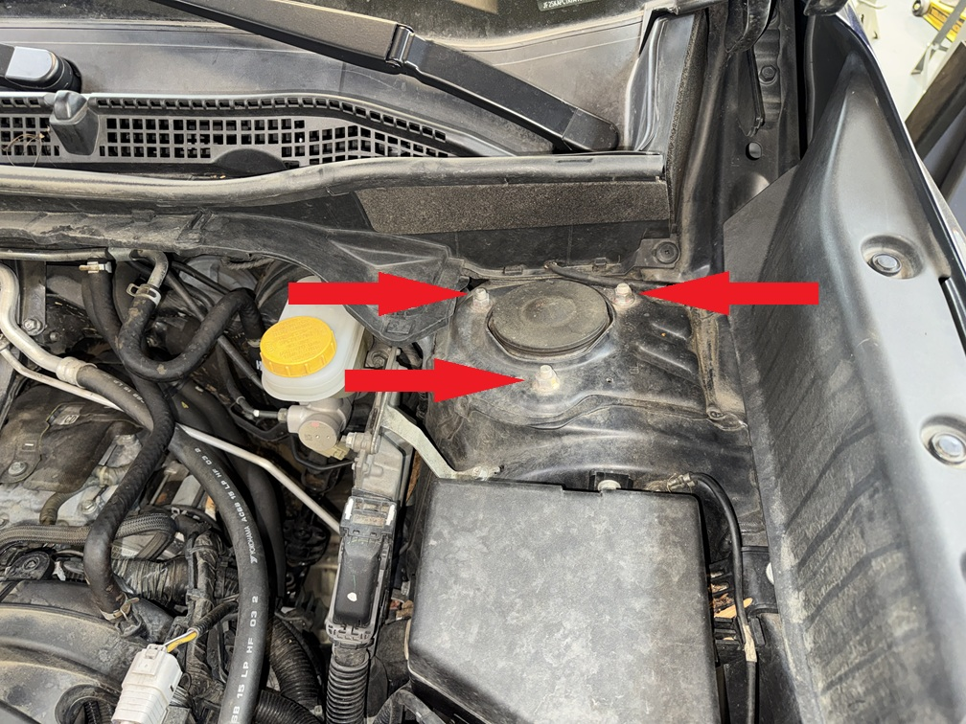
Step 37. Install spacer marked “L” on left side, or DRIVER SIDE in U.S. spec models. Attach spacer to strut using original hardware saved from disassembly. Place ¼” (6.3mm) spacer on top of lift spacer.
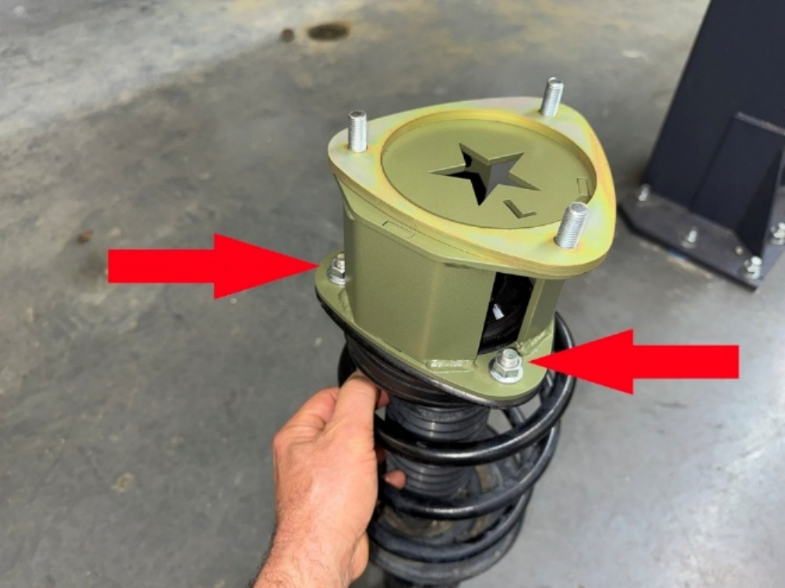
Step 38. Slide driver side strut back into place and mount to vehicle using hardware provided in the kit. Torque bolts to 35 ft-lb. Be sure L is facing as shown in the photo.
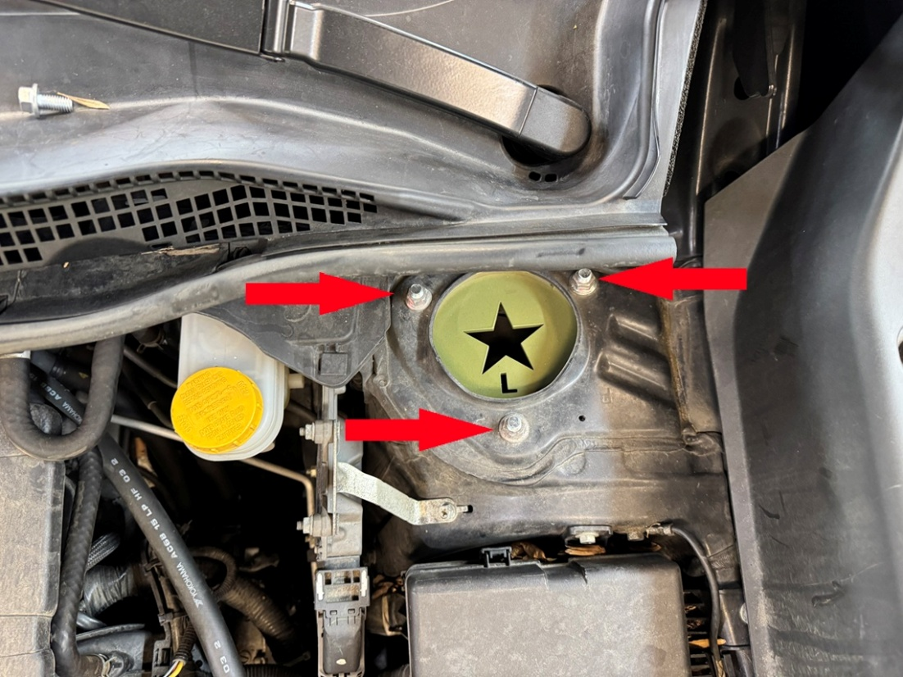
Step 39. Reinstall lower main strut bolt in bottom hole, install eccentric bolt in TOP HOLE. Rotate eccentric bolt to provide maximum negative camber (top of wheel tilting inward). Alignment technician will make final adjustments.
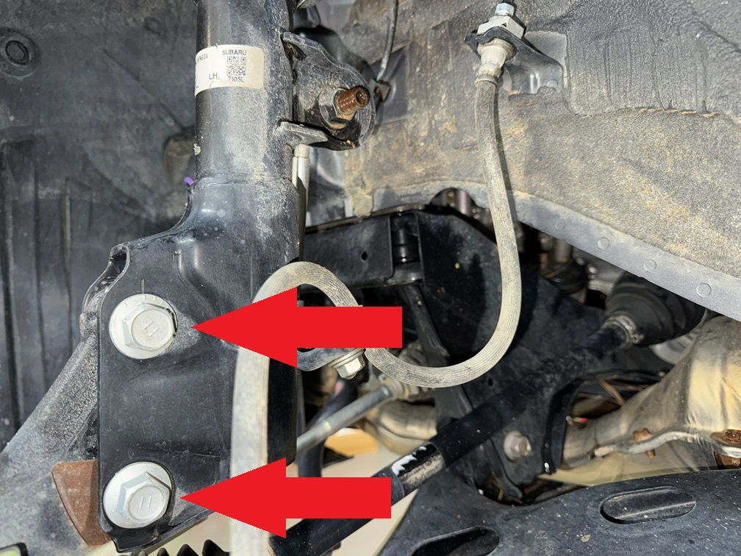
Step 40. Rotate ABS wire 180° as shown. No need to remove clip, just turn it.
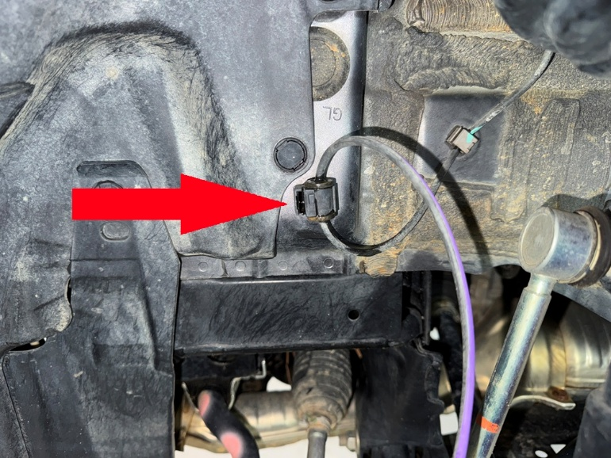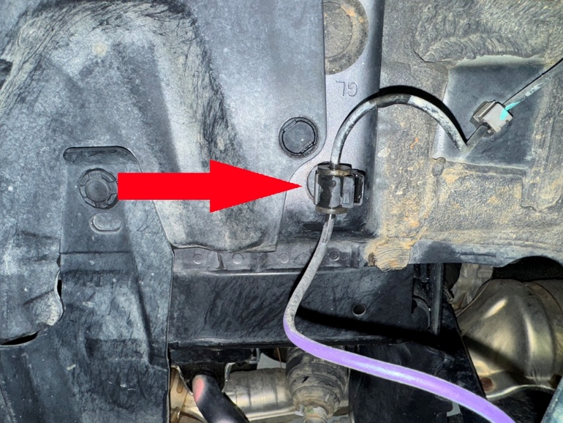
Step 41. Carefully draw ABS wire through mounting grommet to provide additional slack on the wire.
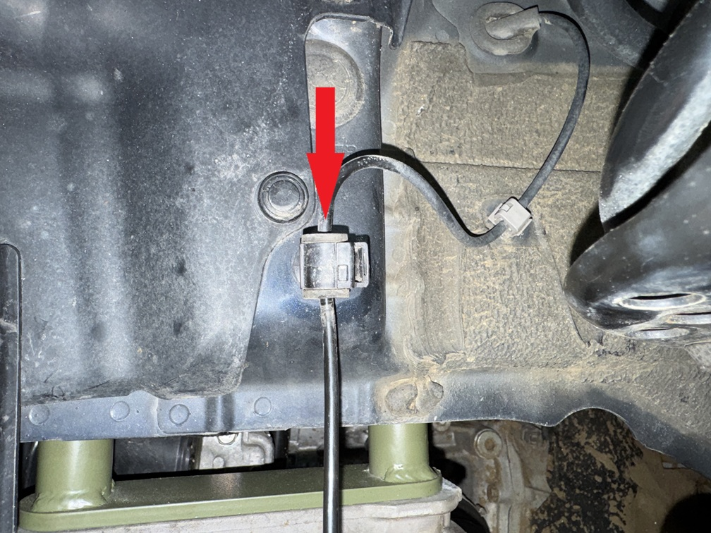
Reattach ABS wire to strut.
Step 42. Install brake line relocation bracket as shown. Torque bolts to 25 ft-lb.
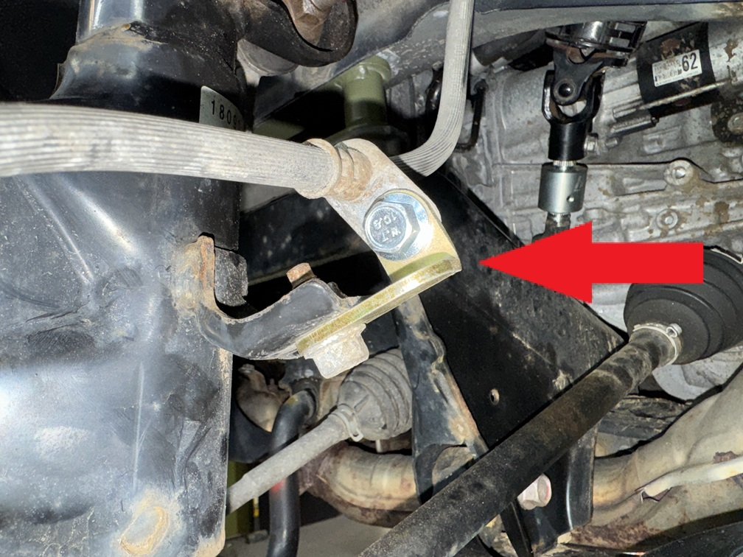
Step 43. Torque main strut nuts to 105 ft-lb.
Step 44. Repeat installation process for passenger side. NOTE: sway bar end links WILL NOT line up until both sides are lifted!
Step 45. Reinstall sway bar end links. Torque nuts to 65 ft-lb
Step 46. Reinstall front wheels.

Rear Installation:
Step 1. Lift vehicle and support with jack stands.
Step 2. Locate and remove 10mm bolts and plastic clips holding gas tank covers. Remove covers.
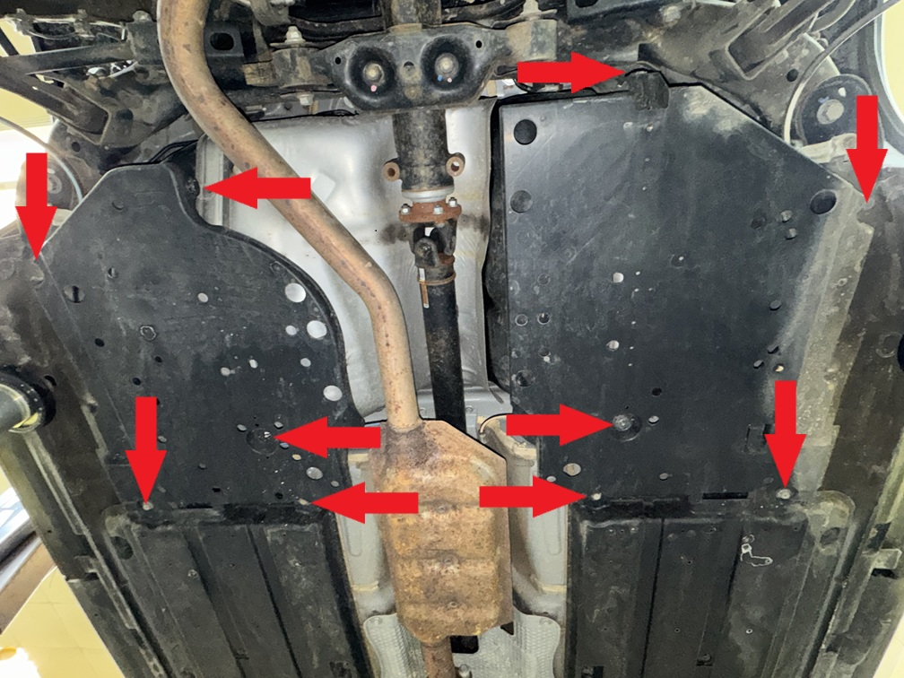
Step 3. Locate and remove bolts holding rear subframe braces, as well as clips holding mud deflectors. Remove mud deflectors.
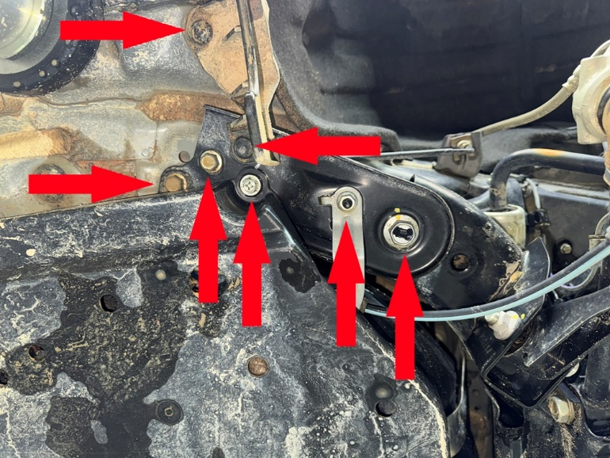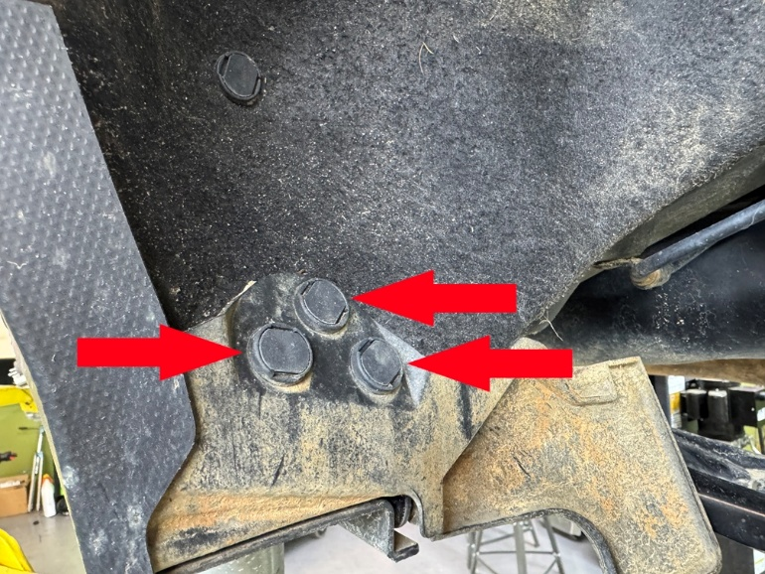
Step 4. Cut notches in gas tank covers as shown:
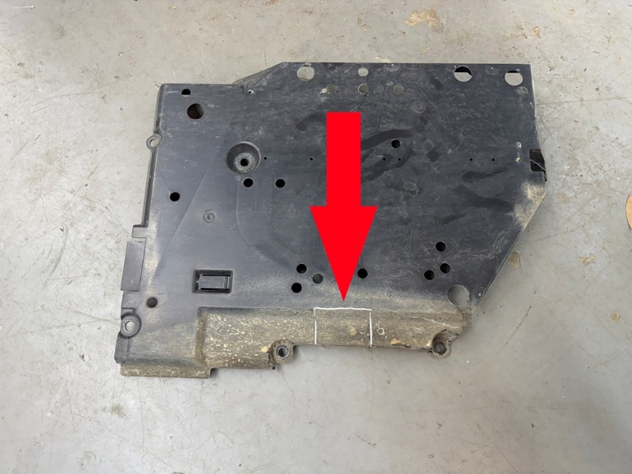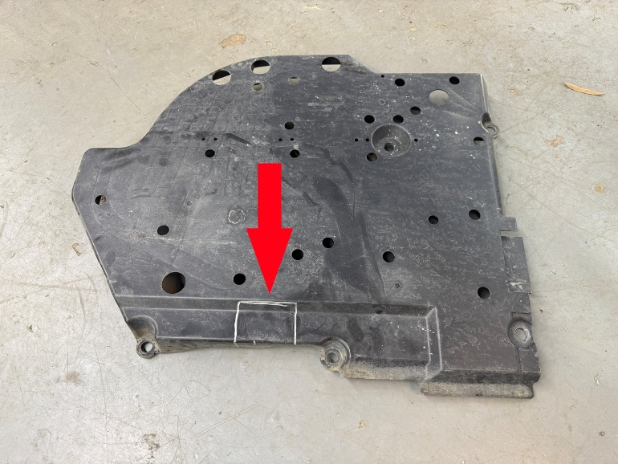
Step 5. Using a floor jack or screw jack, support rear subframe under rear differential.
Step 8. Remove bolts holding sway bar mounting brackets from both driver and passenger side.
Step 6. Locate and remove the “rear-most” 2 of the 4 main rear subframe bolts. Replace with 2 M14x200 bolts provided in the kit to keep the subframe square and in line while lowering.
Step 7. Remove remaining 2 main subframe bolts. (see photo)
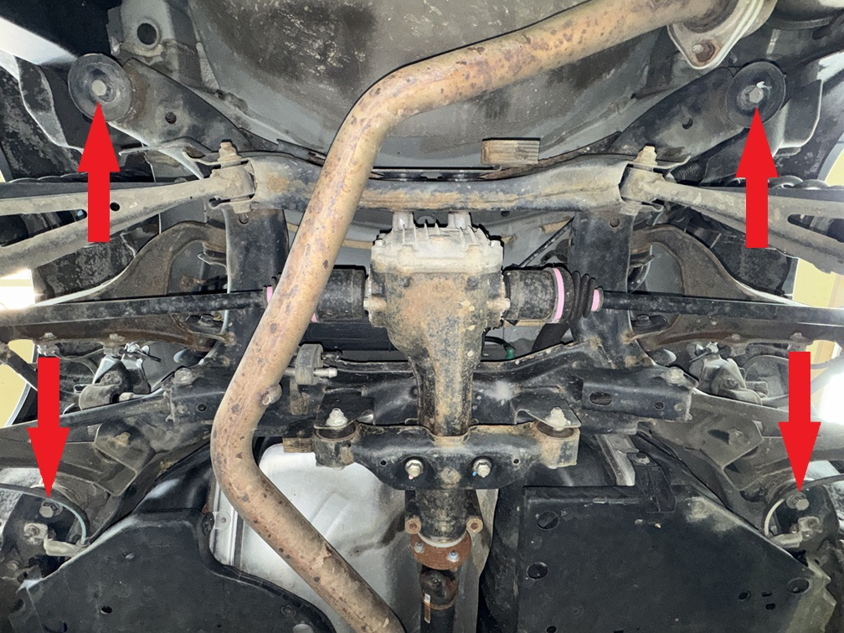
Step 9. Carefully lower rear subframe approximately 2 inches.
Step 10. Place 2.75x2 M14 spacer between subframe and body, install M14x200 bolt, repeat process for all four mounting locations.
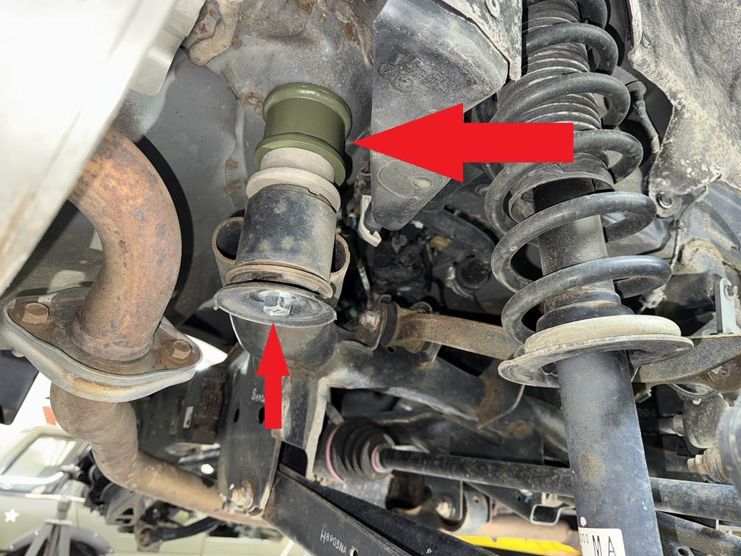
Step 11. Place 2 1x2 M10 spacers between subframe bracket and body, install 2 M10x70 bolts. Torque to 50 Ft-Lb. Torque main bolts to 105+ Ft-lb.
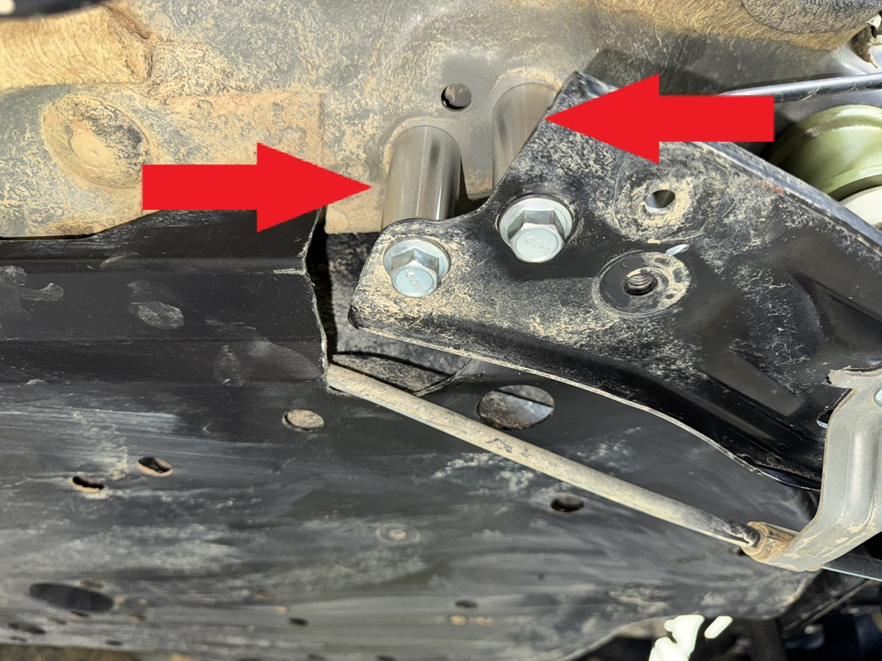
Step 12. Reinstall plastic gas tank covers. Some of the original bolts will not be reused. The subframe brackets will install on the outside of the covers as shown:
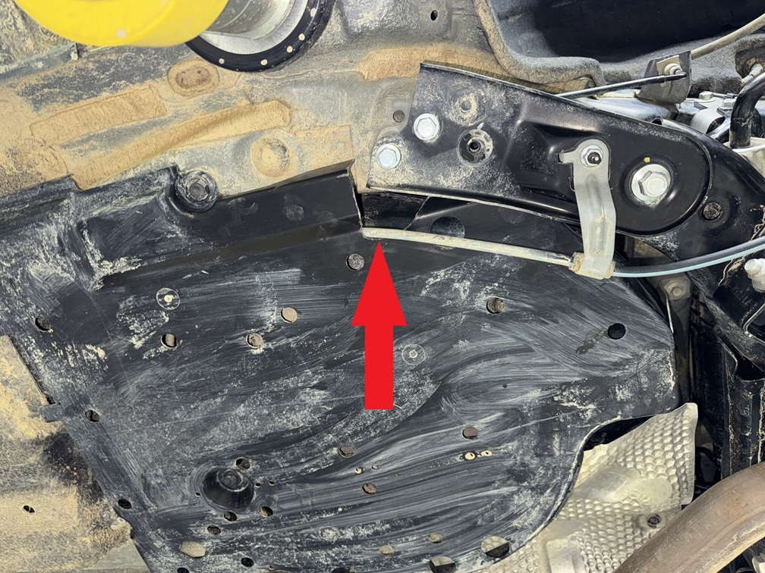
Step 13. Install driver side sway bar relocation bracket as shown. Repeat process for passenger side. If bracket appears not to fit, flip it over.
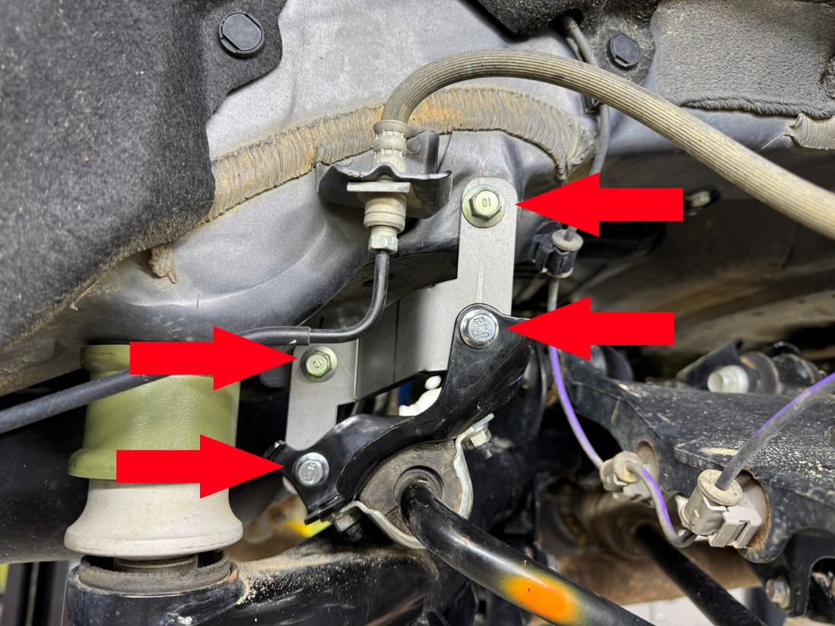
Step 14. Remove rear brake line.
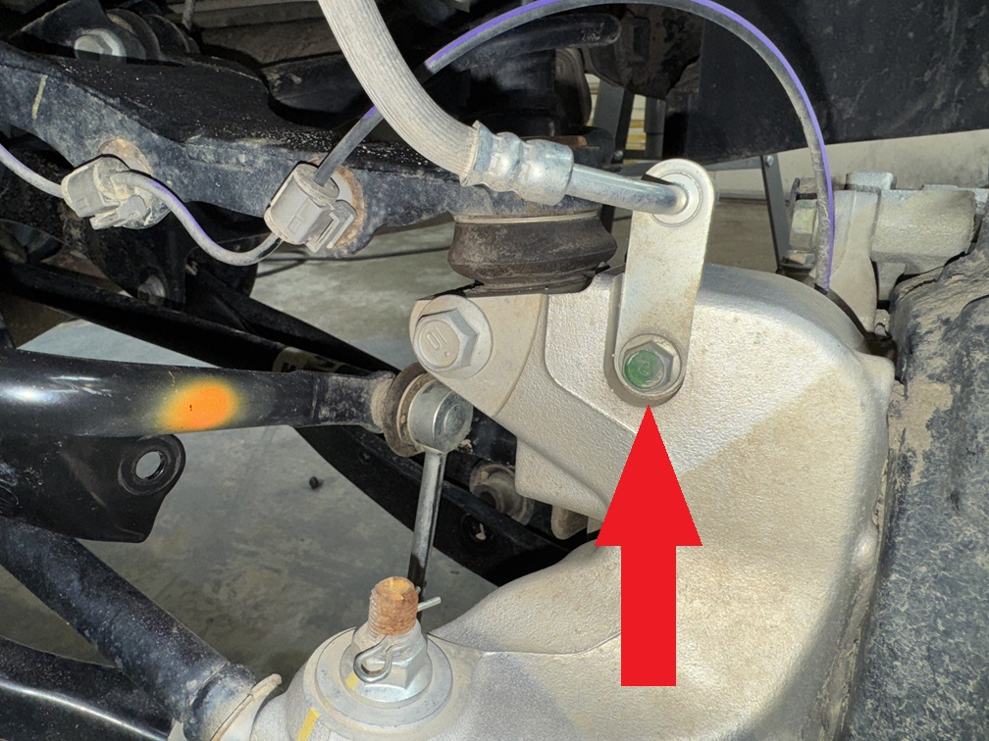
Step 15. Remove lower strut mount bolt and rear knuckle bolt. Loosen, butdo not remove bolt holding lower control arm to subframe. Lower control arm should swing down, allowing strut to be removed.
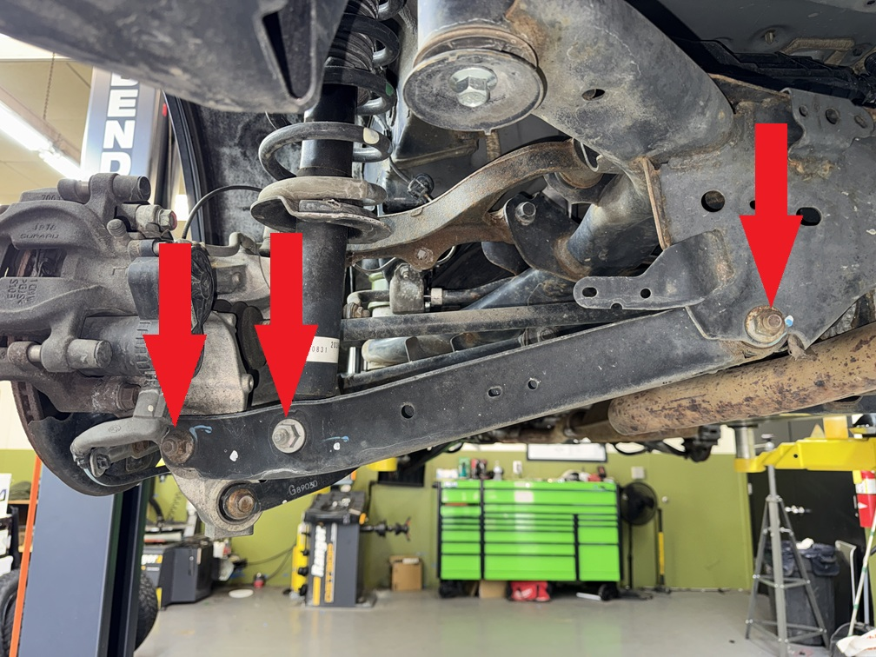
Step 16. Remove cargo liner and carpeted load floor.
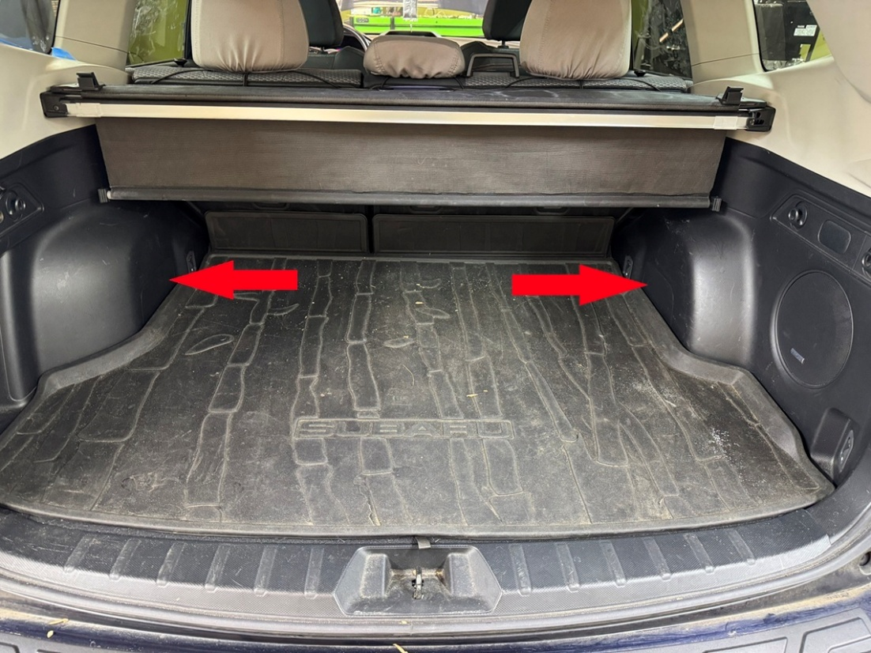
Step 17. Remove plastic clips holding foam piece to trunk floor. Remove foam pieces on both driver and passenger side.
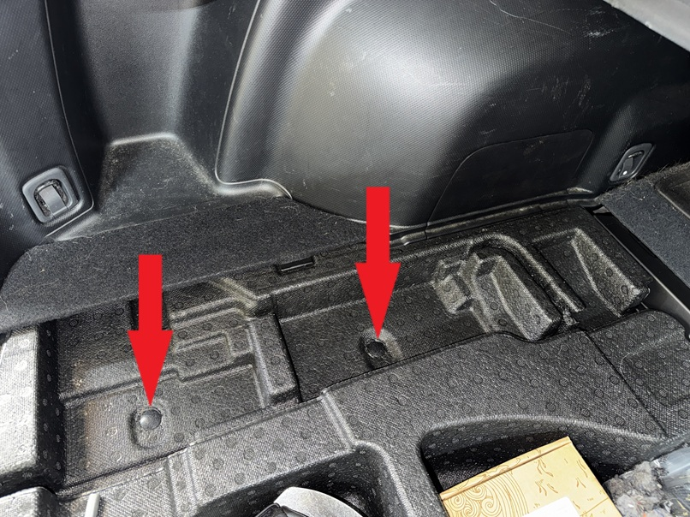
Step 18. Remove plastic cover over rear strut mount.
Step 19. Remove 2 nuts holding rear strut to vehicle. Remove strut. (Save hardware)
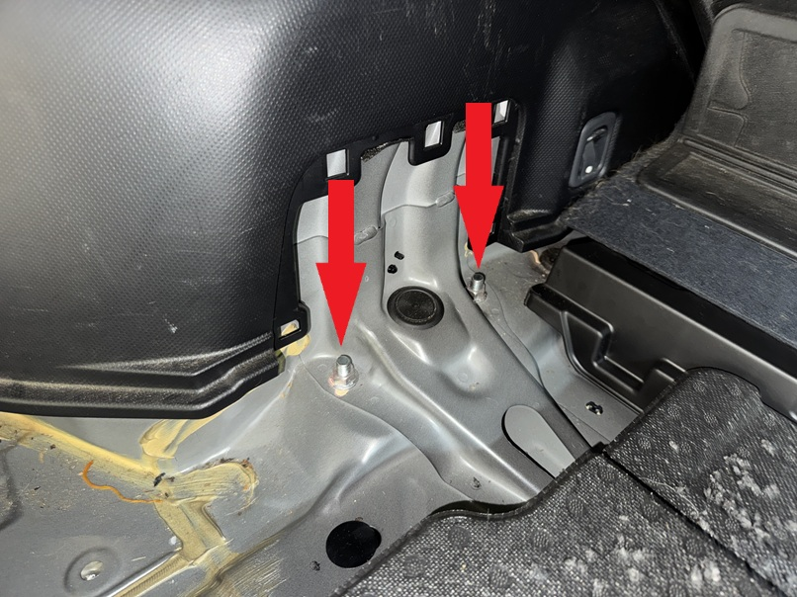
Step 20. Attach spacer to strut using OEM hardware.
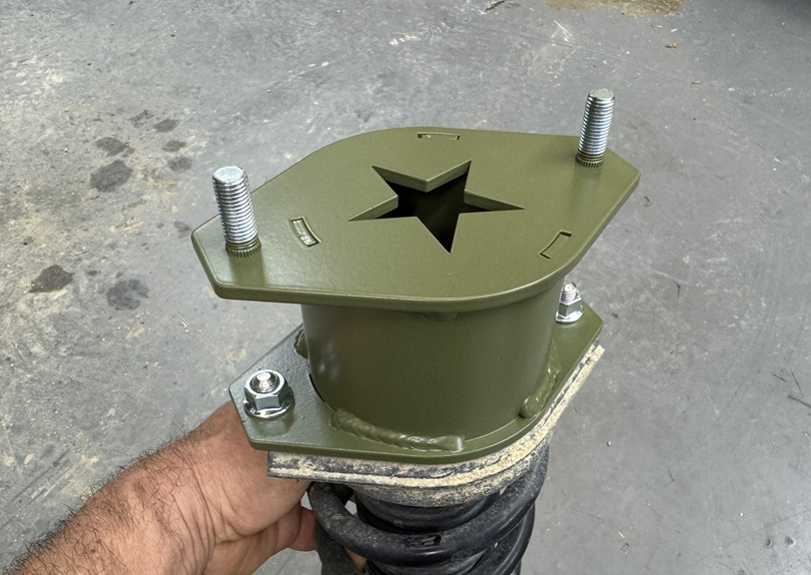
Step 21. Reinstall strut/spacer combo using the nuts provided in the kit.
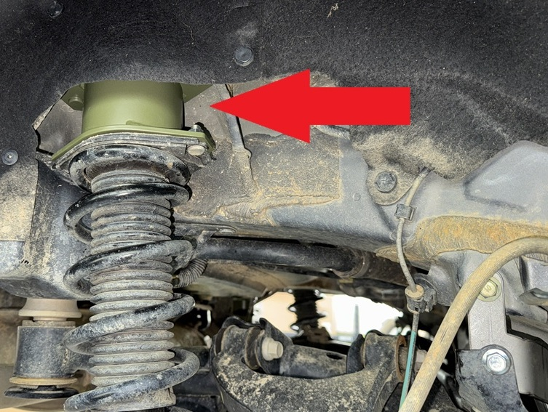
Step 24. Position the lower control arm until the lower strut bolt hole lines up with the bolt hole on the lower control arm. Install mounting bolt (do not tighten).
Step 25. Using a floor jack or screw jack, compress rear strut until lower control arm lines up with knuckle, install mounting bolt.
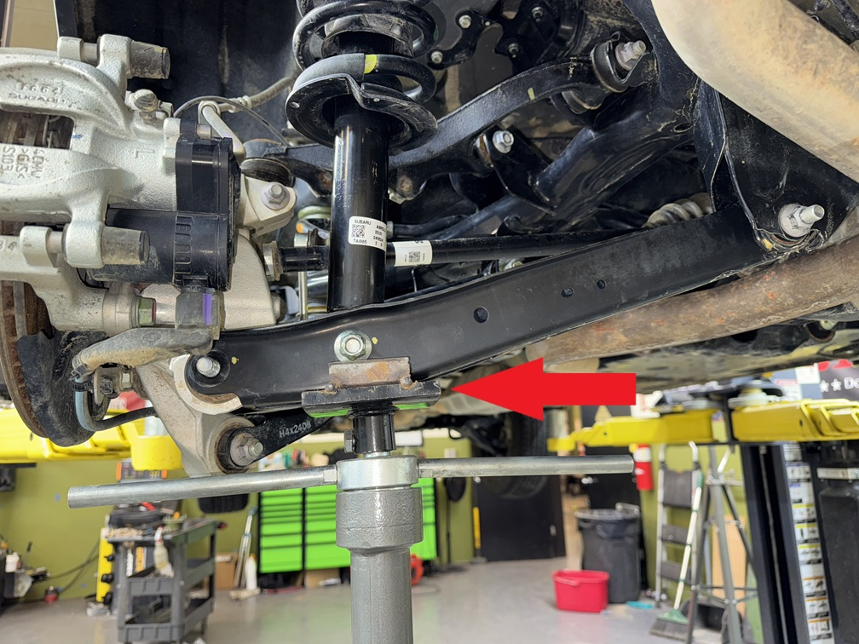
Step 26. Repeat spacer installation process on passenger side.
Step 27. With the suspension compressed, tighten all lower control arm bolts to 85 ft-lb.
Step 28. Install rear brake line extension bracket in factory brake line mounting location on both driver and passenger side. Torque bolts to 25 ft-lb.
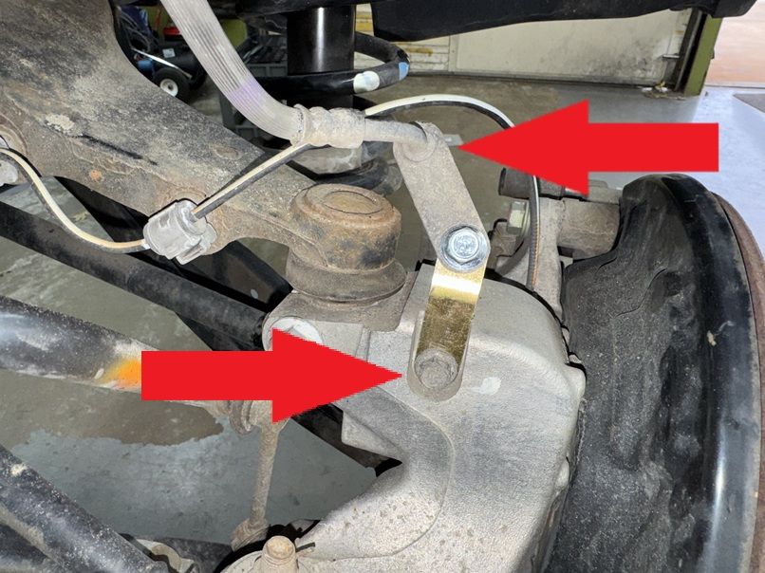
Using a crescent wrench, bend brake line mounting brackets downward to create more slack on the brake line as shown:
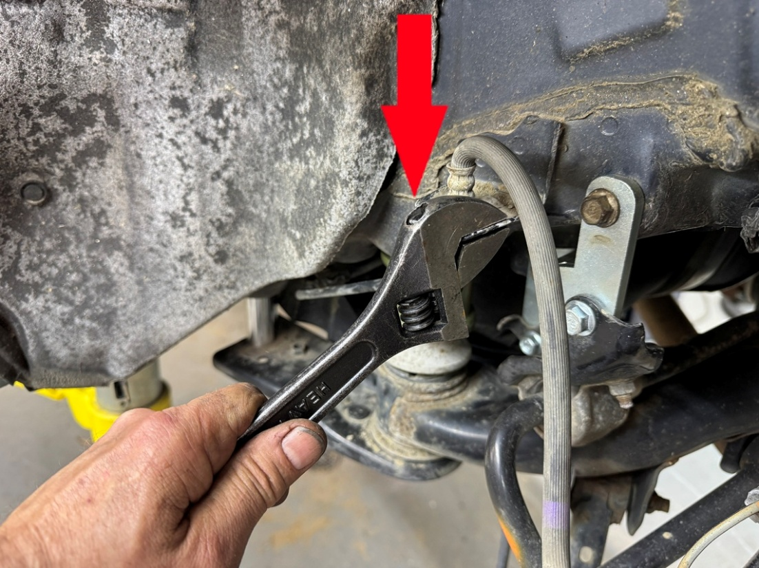
Step 31. Double check ALL BOLTS!
Step 32. Reinstall wheels and lower vehicle.
Step 23. Reinstall interior panels and cargo liner.
Step 33. Get a professional alignment.
Step 34. Find some trails!!
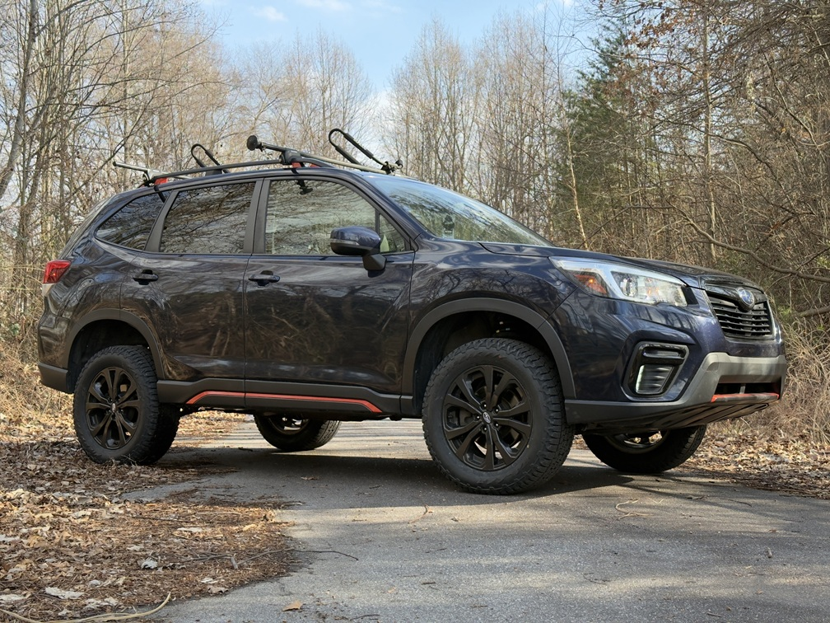
Troubleshooting noises after the installation:
- Rattling from front while going over bumps: Check sway bar end link nuts. Most common cause.
- Rattling from rear while going over bumps: Check sway bar mounting brackets. Be sure all bolts are tight.
- Creaking while driving either front or rear: Check subframe bolts.
- Scraping noise while driving: Check brake dust shields. Bend away from brake rotors as needed.
- Engine sounds louder than usual: check dog bone bolts. Loosen and re-tighten.
Note: Installing lift spacers will change the suspension geometry and will require a 4 wheel alignment.
Warning: Failure to follow the procedures in these installation instructions may result in unsafe handling characteristics, damage to vehicle, or loss of control.
For tech support, please call 1-844- HRG LIFT (474-5438) from 8-4:30 PM EST Mon-Thu 8-3:30 PM Fri or email us 24/7 at support@hrgoffroad.com.
This product is intended for off-road use only!!
Copyright HRG Offroad 2026

2019-2024 Subaru Forester and Forester Wilderness 4" lift kit
Checklist:
__ OUT2024 3.0F(1L,1R)
__ FOR0913 3.0R (2)
__ FOR9808 SHIM (2)
__ 2.0 SSE (1) steering shaft extension 3 m6 set screws
__ Bent BLBL (1L, 1R)
__ Bent BLB2 (1 pack)
__ 2” Subaru ECS (2)engine cradle spacers
__ 2” CRO-FLCAS (1L, 1R)front lower control arm spacers
__ CRO24+RSBRB (2)rear sway bar relocation brackets. 2 m8x16 2 m8 nuts per
__ CRO24+DBRB (2) dog bone relocation brackets.
__ FOR19-24 VHRB (1) vacuum hose relocation bracket m6x16, m6 nut
__ 2.75x2 M14 (4)
__ 1x2 M10 (12)
__ 0.75x1/M8x40 (1 pack of 4)
BOLT PACK
__ M12x160 (4)
__ M14x160 (2)
__ M14x200 (4)
__ M14x70 (4)
__ M10x70 (10)
__ M10x90 (2)

