

2019-2024 Subaru Forester and Forester Wilderness 1.5” (38mm) lift kit installation guide
Professional installation is recommended
IMPORTANT!
Lifting and modifying the suspension on your vehicle may result in drive line vibrations, damaged bushings, erratic handling characteristics, and shortened suspension component life. HRG Offroad recommends the following:
-Checking and/or replacing worn drive axles with new parts, not remanufactured.
-Checking and/or replacing all worn factory rubber bushings with urethane bushings, such as Prothane.
-Checking and/or replacing worn shock absorbers and bump stops.
-Performing a 4 wheel alignment after working on suspension components.
Lift kits may not be legal for use on public highways in your area. Please check local laws before installing!!
WARNING!
Lifted vehicles are more prone to rolling over.
Some HRG Offroad products are designed to improve off-road capabilities. Modifying the suspension of your vehicle may result in handling characteristics that are different from a factory equipped vehicle. Extreme care must be used to prevent a rollover or loss of control. Always operate your modified vehicle at a reduced speed to ensure your ability to maintain control under all driving conditions. Driving your vehicle in an unsafe manner may result in serious injury or death. HRG Offroad lift kits are designed and tested to work together. HRG Offroad does not recommend combining this lift kit with any other type of suspension or body lift. Always wear your seat belt.
Recommended tire/wheel sizes:
Stock: 225/60/17 (27.6”)
ALL 17” SIZES ASSUME STOCK WHEELS!
235/60/17 (28.1")
225/65/17 (28.5”)
235/65/17 (29”)
245/65/17 (29.5”)
EXTREME SIZE: 235/70/17 (30”) WILL require fender/pinch weld trimming
Stock: 225/55/18 (27.7”)
ALL 18” SIZES ASSUME STOCK WHEELS!
235/55/18 (28.2)
245/55/18 (28.6)
245/60/18 (29.5”)
EXTREME SIZE: 235/65/18 (30”) WILL require fender/pinch weld trimming
Be sure to check fitment prior to installation! These sizes are only suggestions. HRG is not responsible for improperly fitted wheels/tires!

Included in the kit:
2 1.5” (38mm) offset lift spacers (front)
2 1.5" (38mm) lift spacers (rear)
6 M10 nuts (front)
4 M10 nuts (rear)
2 rear brake line relocation brackets
4 M8x16 bolts (brake line brackets)
4 M8 nuts (brake line brackets)
2 rear sway bar relocation brackets
4 M8x16 bolts (rear sway bar relocation brackets)
4 M8 nuts (rear sway bar relocation brackets)
4 2.75x1 M14 spacers (rear subframe)
4 M14x180 bolts (rear subframe)
4 1x1 M10 spacers (rear subframe braces)
4 M10x50 bolts (rear subframe braces)
Tools required:
Floor jack, lug wrench, metric socket set up to 21mm, metric wrench set up to 19mm, panel puller, hex key set, common pliers, pipe wrench, plastic cutting tool, pry bar, torque wrench.
Approximate installation time: 2-4 hours
Skill level: Easy
Front installation:
Remove bolts holding the brake line, the nut holding the sway bar end link and un-clip ABS wiring from the driver side strut.
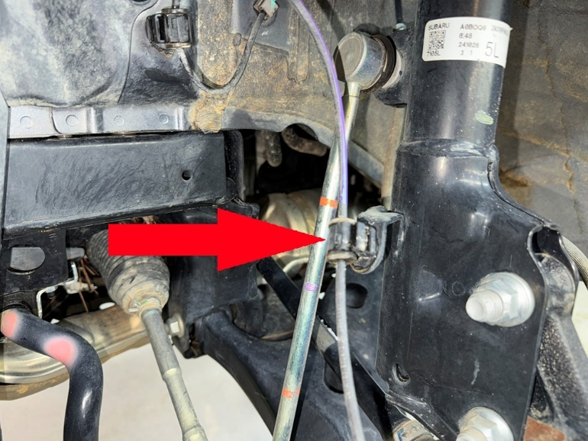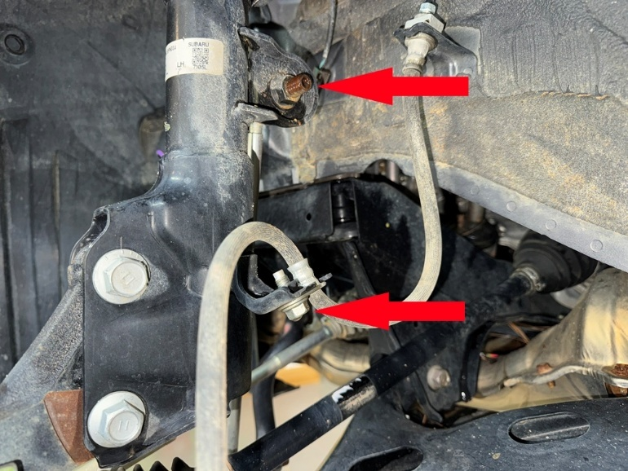
Step 35. Using a 19mm socket, remove 2 large nuts on bottom of strut, and tap bolts out with a heavy hammer.
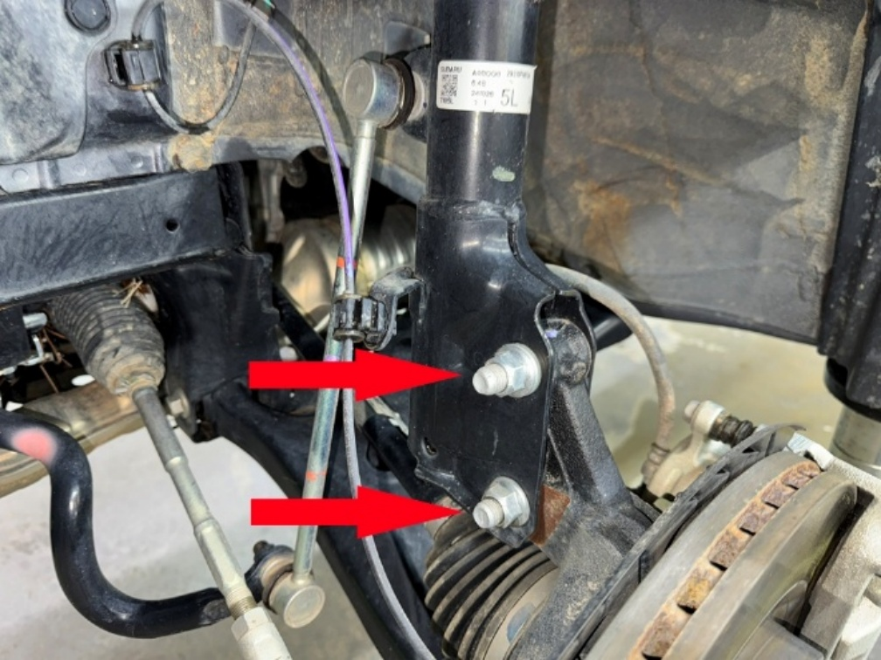
Step 36. Remove 3 M8 nuts from strut top to allow strut to drop out. (save hardware).
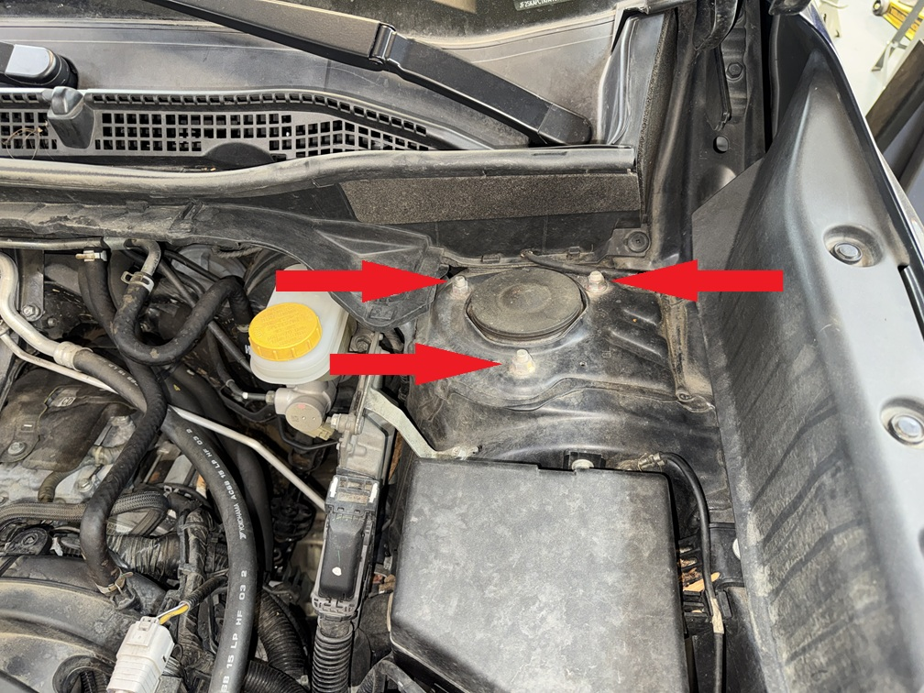
Step 37. Install spacer marked “L” on left side, or DRIVER SIDE in U.S. spec models. Attach spacer to strut using original hardware saved from disassembly. Place ¼” (6.3mm) spacer on top of lift spacer.
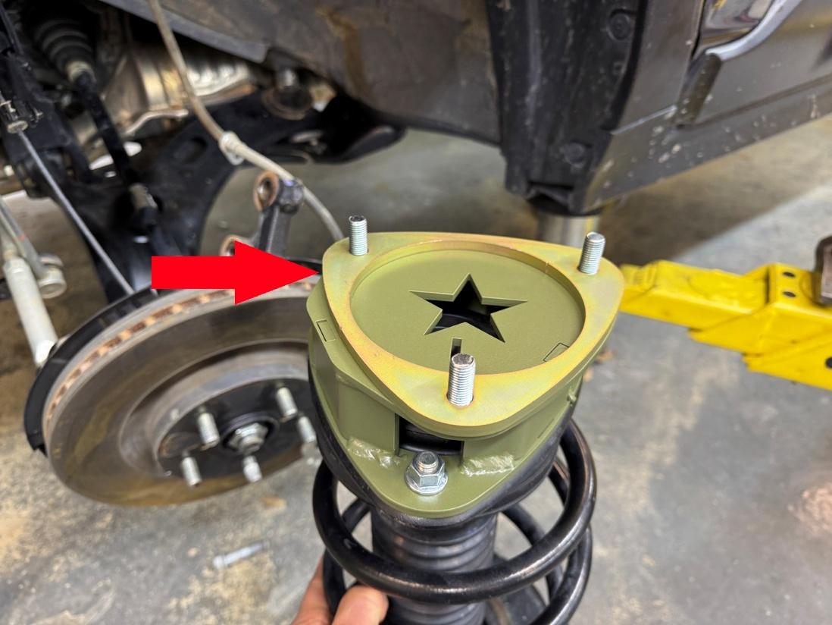
Step 38. Slide driver side strut back into place and mount to vehicle using hardware provided in the kit. Torque bolts to 35 ft-lb. Be sure L is facing as shown in the photo.
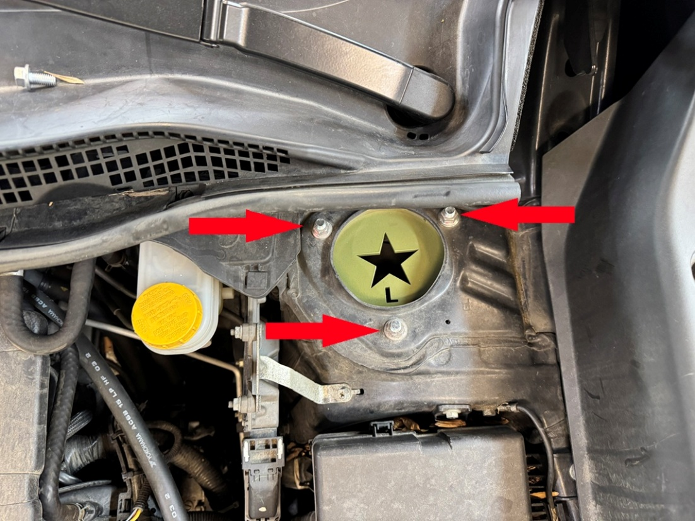
Step 39. Reinstall lower main strut bolt in bottom hole, install eccentric bolt in TOP HOLE. Rotate eccentric bolt to provide maximum negative camber (top of wheel tilting inward). Alignment technician will make final adjustments.
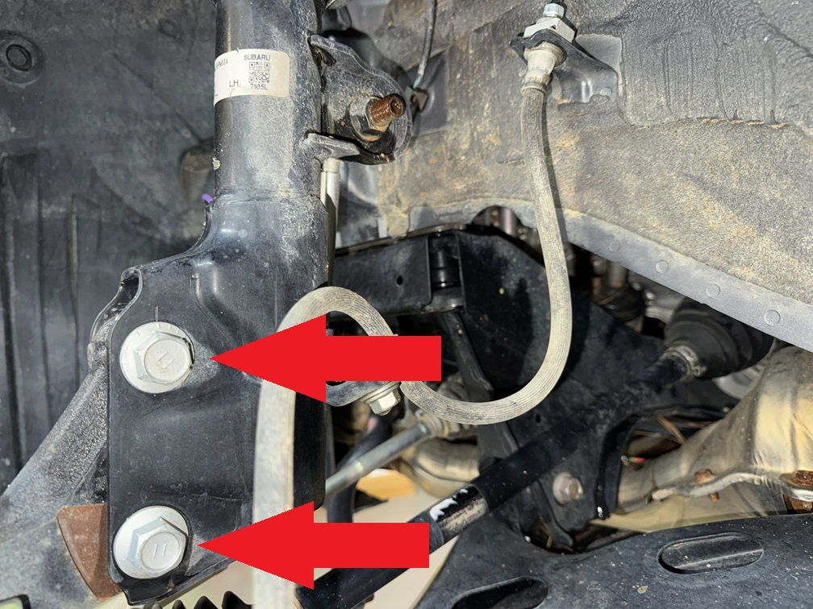
Step 40. Rotate ABS wire 180° as shown. No need to remove clip, just turn it.
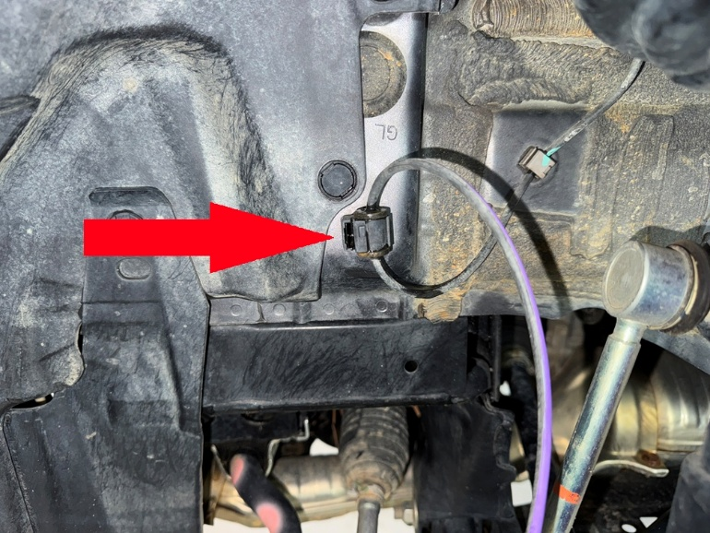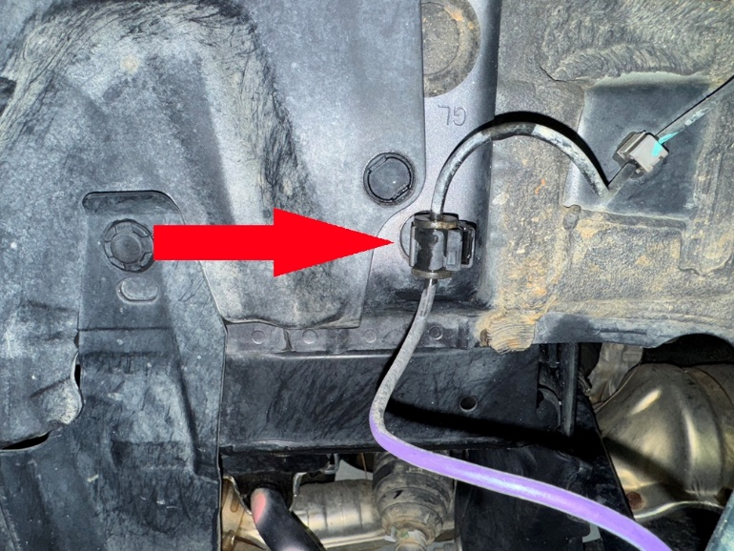
Reattach ABS wire to strut.
Step 42. Install brake line relocation bracket as shown. Torque bolts to 25 ft-lb.
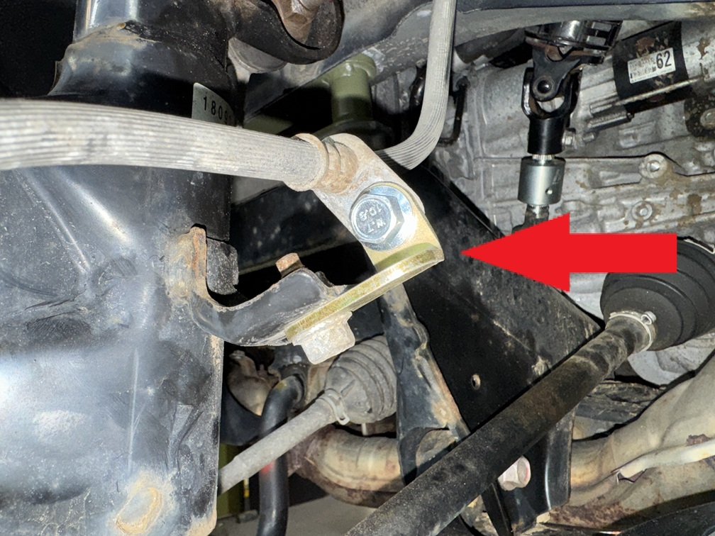
Step 43. Torque main strut nuts to 105 ft-lb.
Step 44. Repeat installation process for passenger side. NOTE: sway bar end links WILL NOT line up until both sides are lifted!
Step 45. Reinstall sway bar end links. Torque nuts to 65 ft-lb
Step 46. Reinstall front wheels.

Rear Installation:
Step 1. Lift vehicle and support with jack stands.
Step 2. Locate and remove 10mm bolts and plastic clips holding gas tank covers. Remove covers.
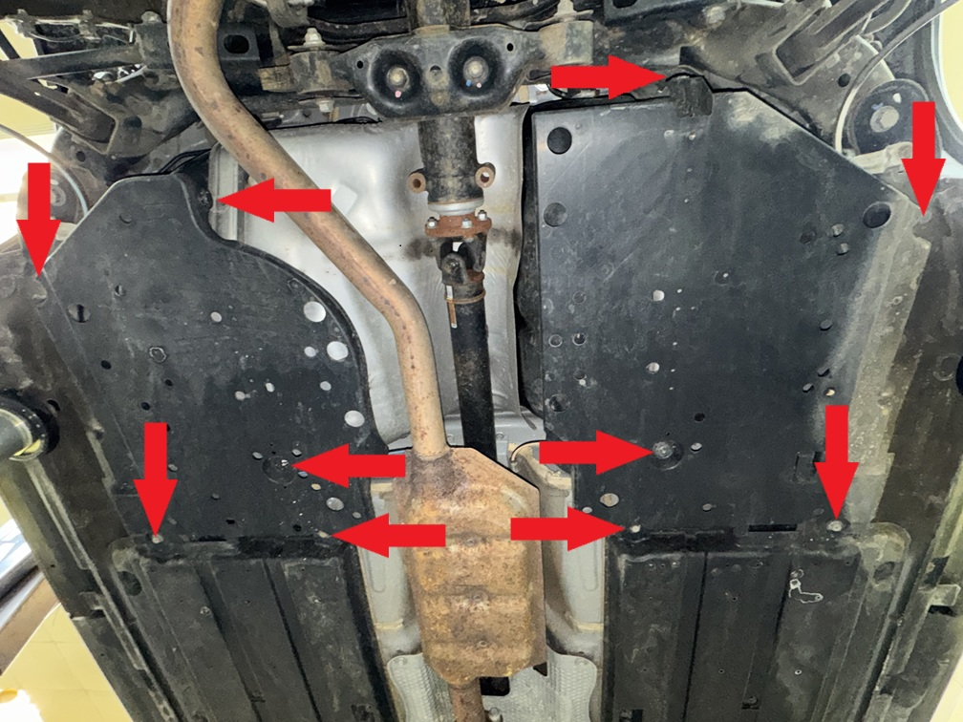
Step 3. Locate and remove bolts holding rear subframe braces, as well as clips holding mud deflectors. Remove mud deflectors.
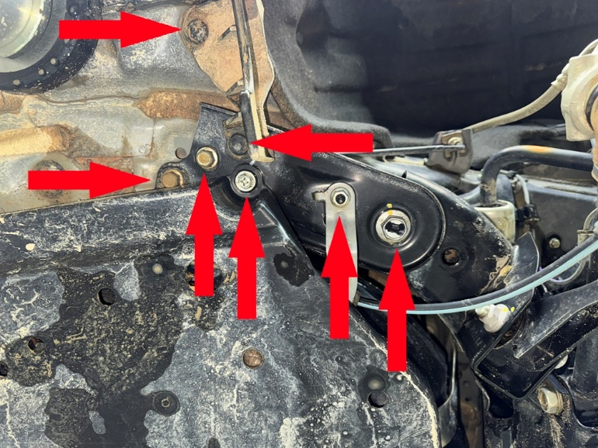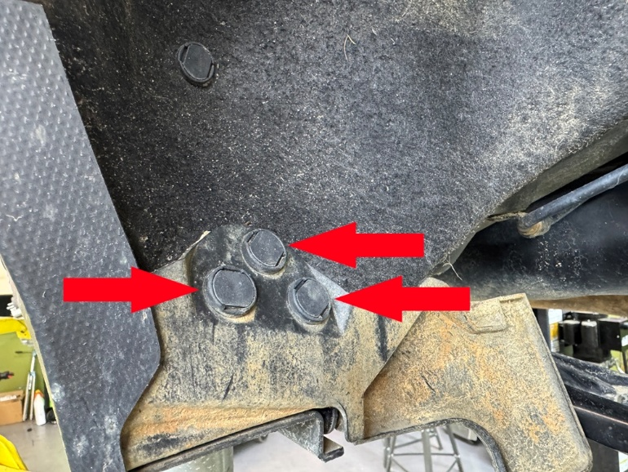
Step 4. Cut notches in gas tank covers as shown:
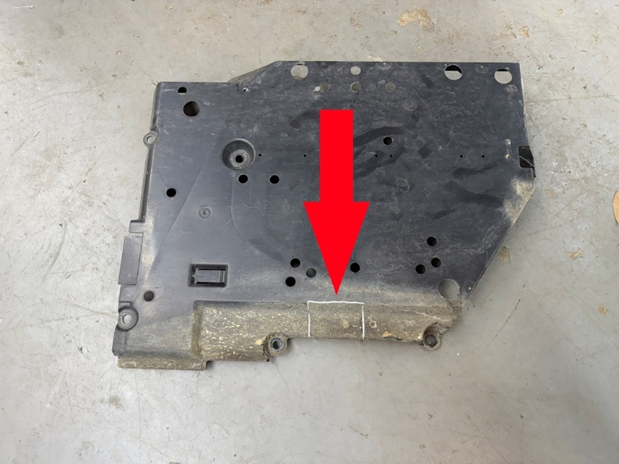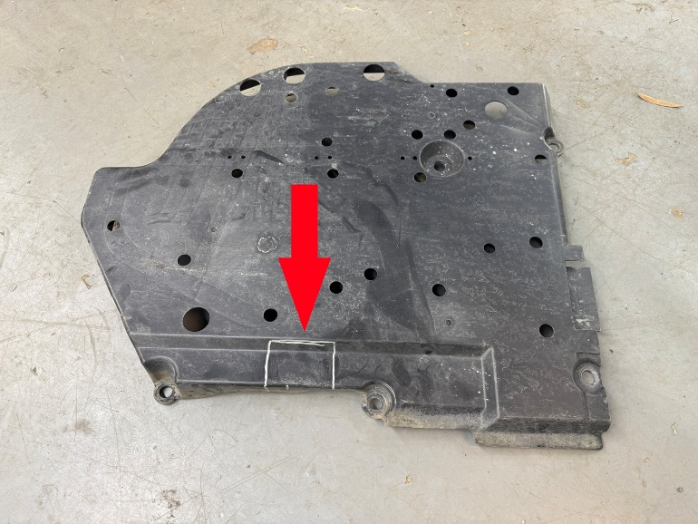
Step 5. Using a floor jack or screw jack, support rear subframe under rear differential.
Step 8. Remove bolts holding sway bar mounting brackets from both driver and passenger side.
Step 6. Locate and remove the “rear-most” 2 of the 4 main rear subframe bolts. Replace with 2 M14x200 bolts provided in the kit to keep the subframe square and in line while lowering.
Step 7. Remove remaining 2 main subframe bolts. (see photo)
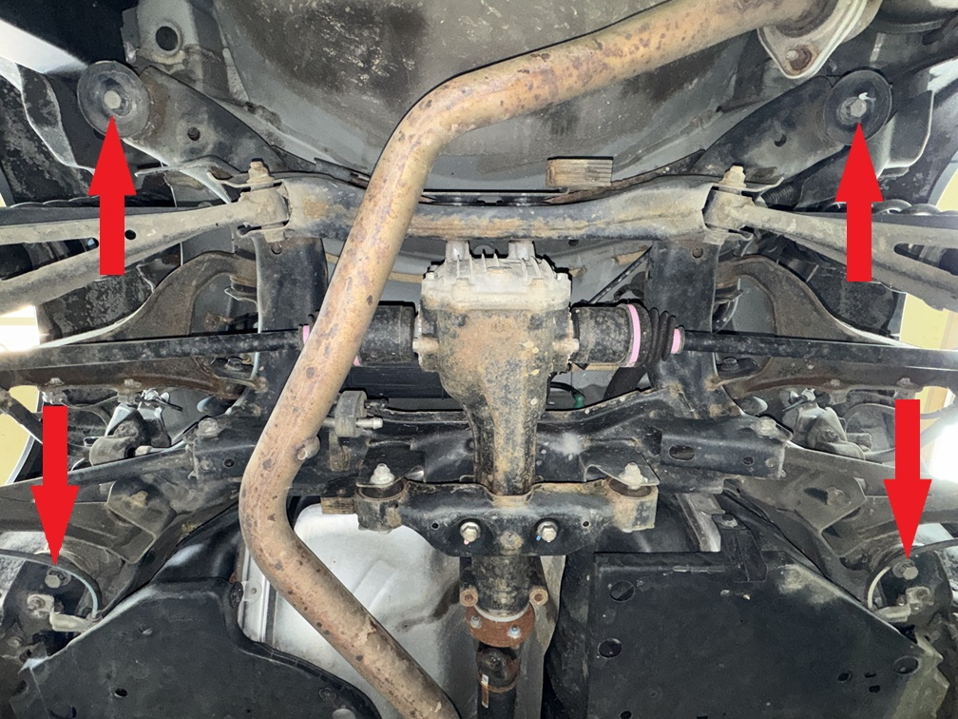
Step 9. Carefully lower rear subframe approximately 2 inches.
Step 10. Place 2.75x2 M14 spacer between subframe and body, install M14x200 bolt, repeat process for all four mounting locations.
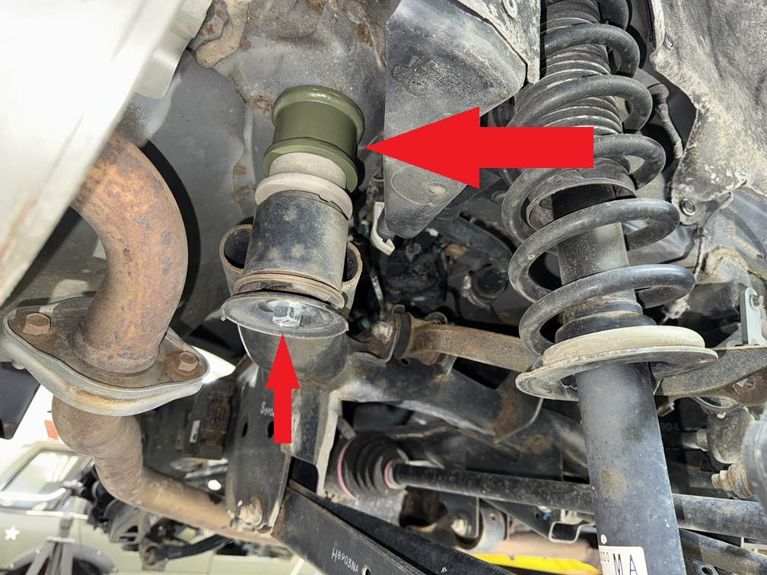
Step 11. Place 2 1x2 M10 spacers between subframe bracket and body, install 2 M10x70 bolts. Torque to 50 Ft-Lb. Torque main bolts to 105+ Ft-lb.
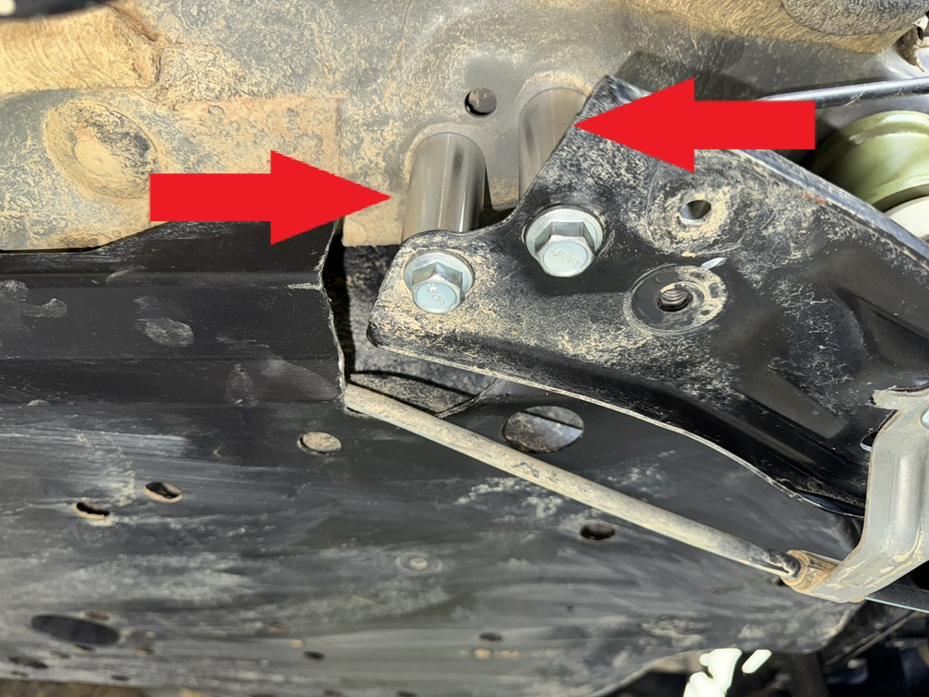
Step 12. Reinstall plastic gas tank covers. Some of the original bolts will not be reused. The subframe brackets will install on the outside of the covers as shown:
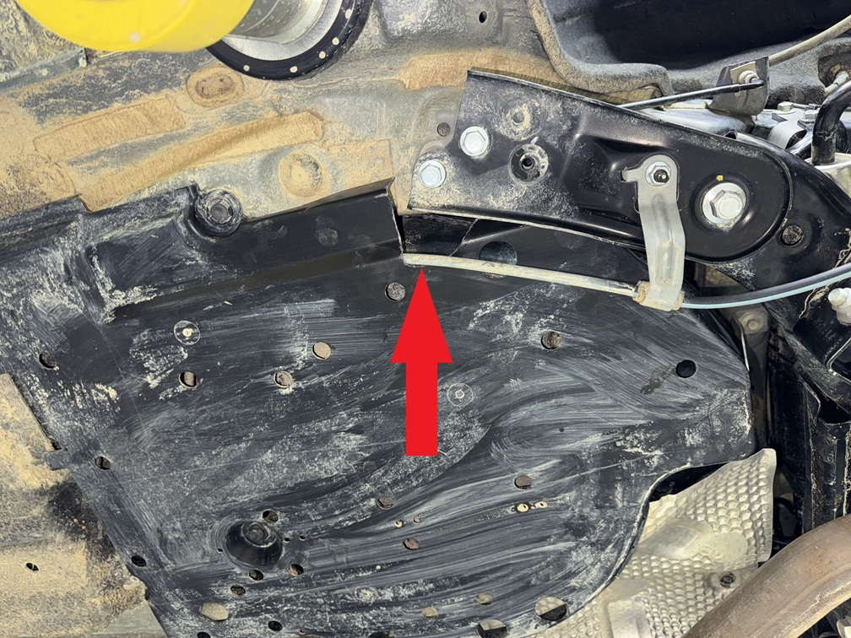
Step 13. Install driver side sway bar relocation bracket as shown. Repeat process for passenger side. If bracket appears not to fit, flip it over.
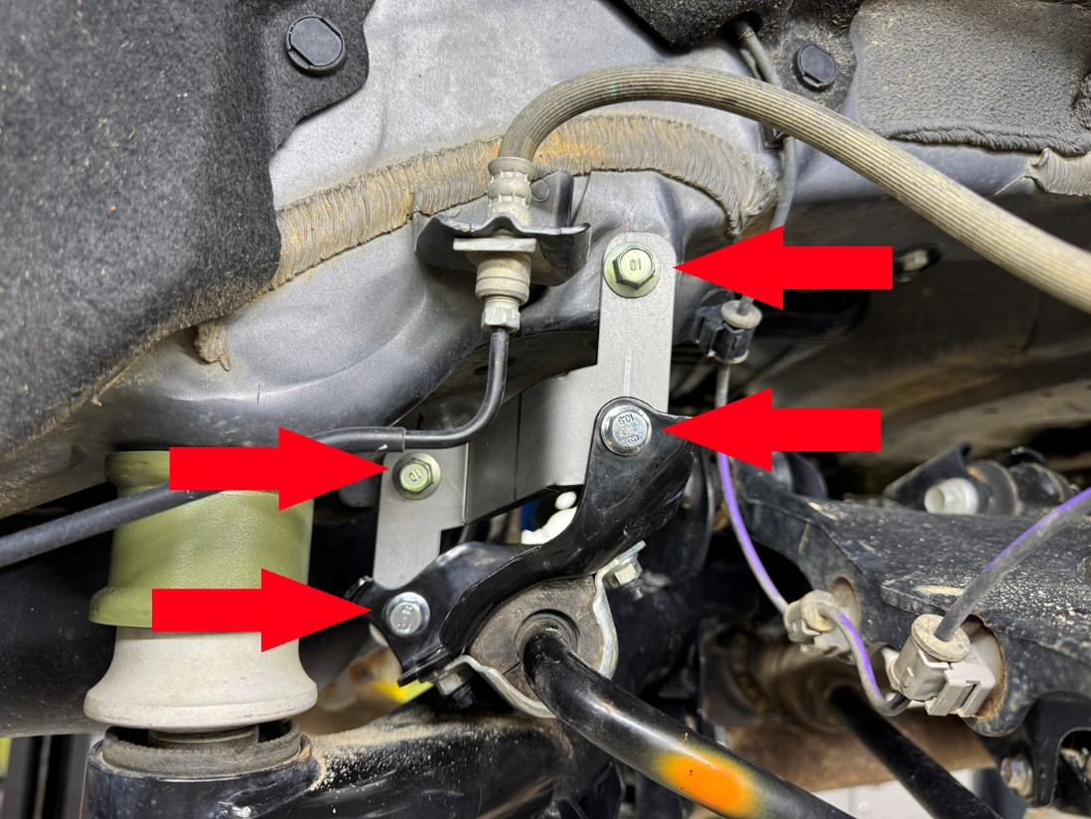
Step 14. Remove rear brake line.
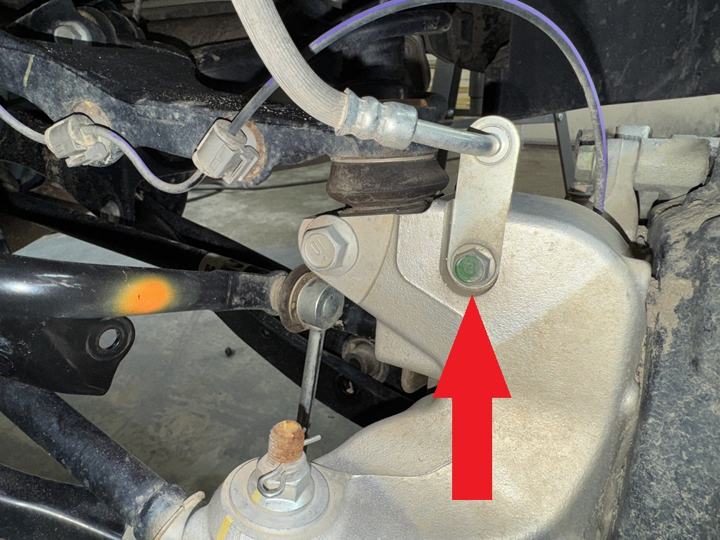
Step 15. Remove lower strut mount bolt and rear knuckle bolt. Loosen, butdo not remove bolt holding lower control arm to subframe. Lower control arm should swing down, allowing strut to be removed.
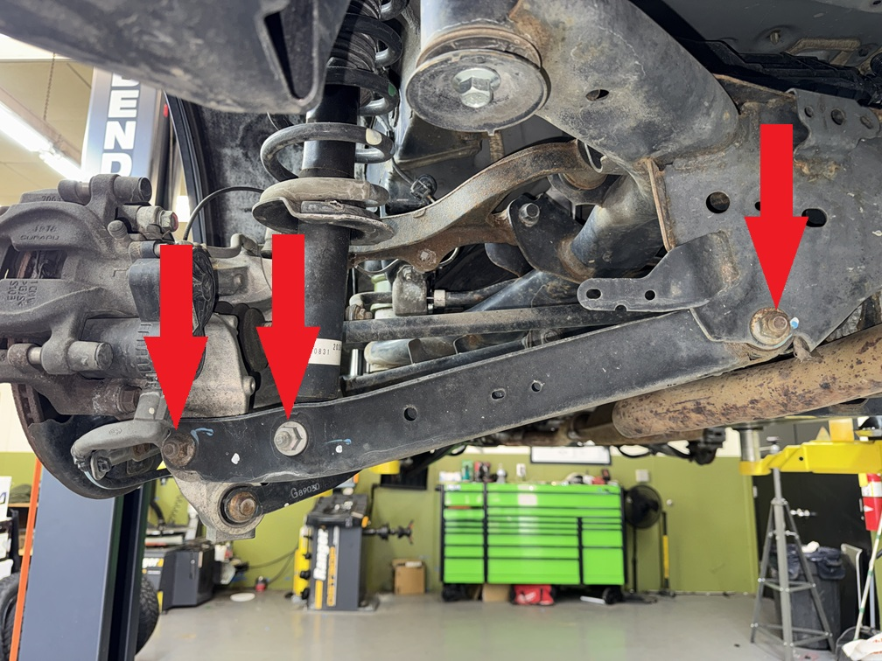
Step 16. Remove cargo liner and carpeted load floor.
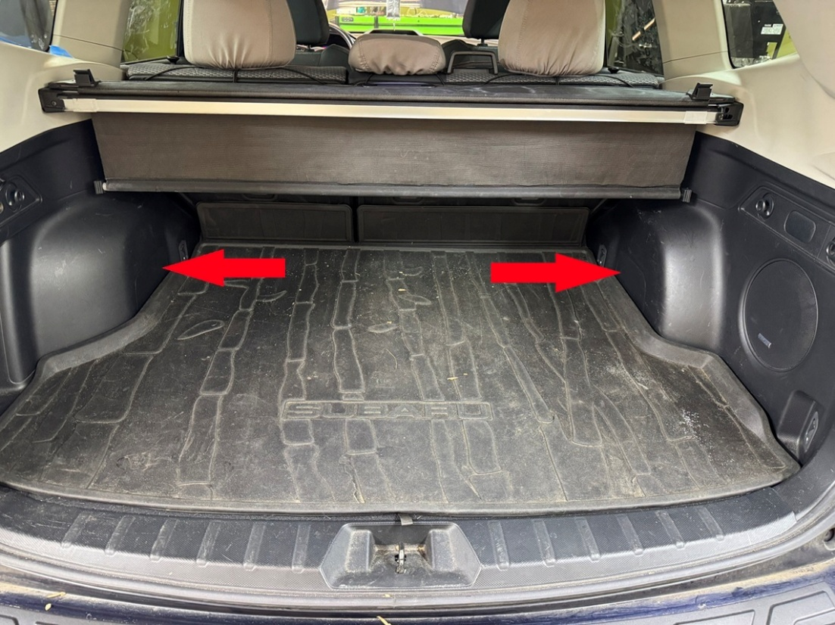
Step 17. Remove plastic clips holding foam piece to trunk floor. Remove foam pieces on both driver and passenger side.
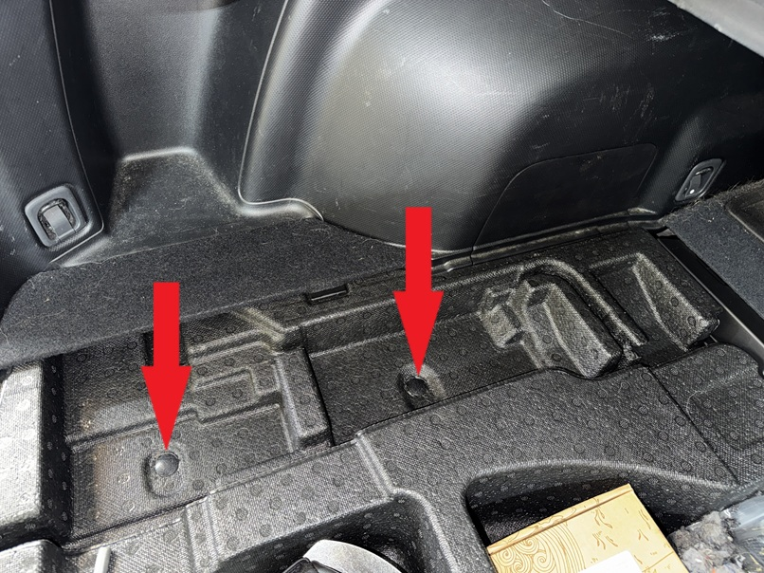
Step 18. Remove plastic cover over rear strut mount.
Step 19. Remove 2 nuts holding rear strut to vehicle. Remove strut. (Save hardware)
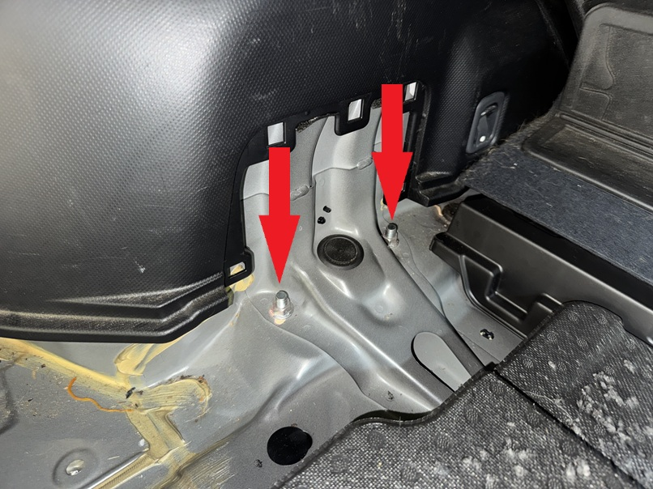
Step 20. Attach spacer to strut using the hardware included with the kit.
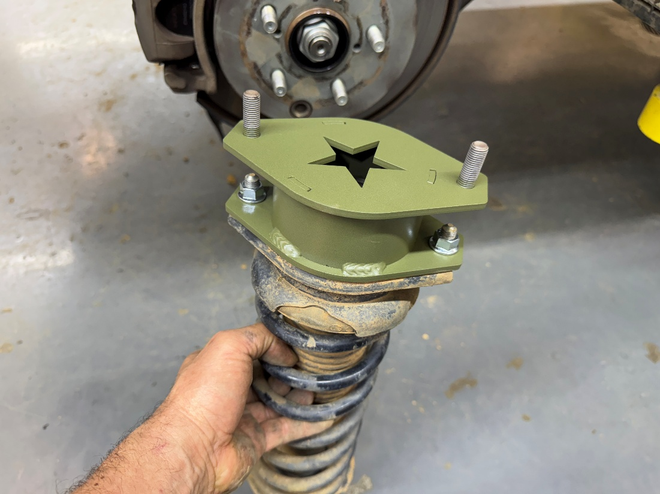
Step 21. Reinstall strut/spacer combo using the OEM hardware.
Step 24. Position the lower control arm until the lower strut bolt hole lines up with the bolt hole on the lower control arm. Install mounting bolt (do not tighten).
Step 25. Using a floor jack or screw jack, compress rear strut until lower control arm lines up with knuckle, install mounting bolt.
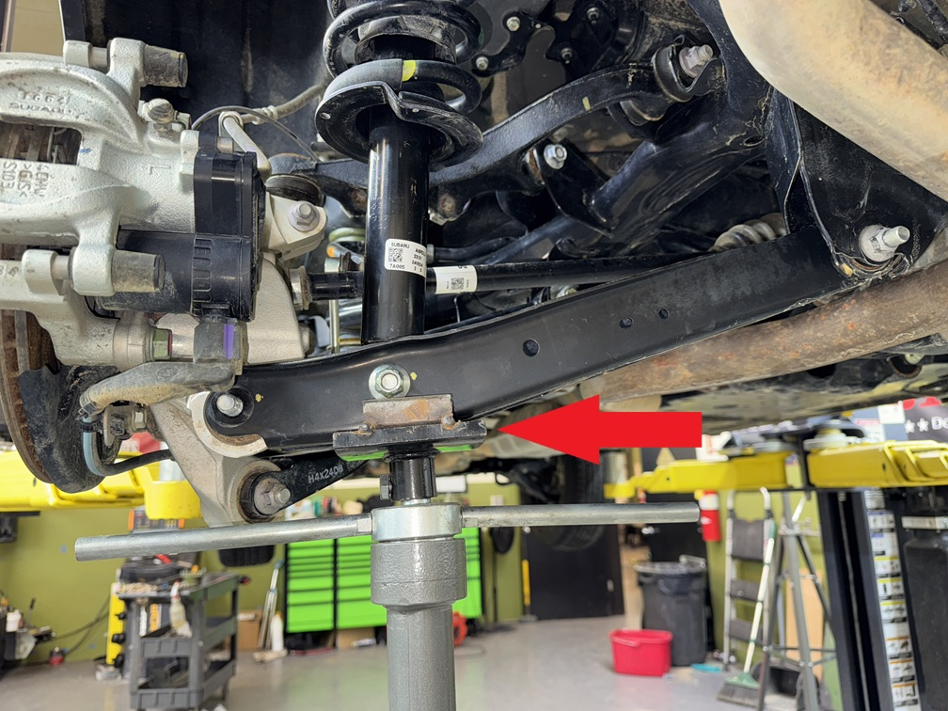
Step 26. Repeat spacer installation process on passenger side.
Step 27. With the suspension compressed, tighten all lower control arm bolts to 85 ft-lb.
Step 28. Install rear brake line extension bracket in factory brake line mounting location on both driver and passenger side. Torque bolts to 25 ft-lb.
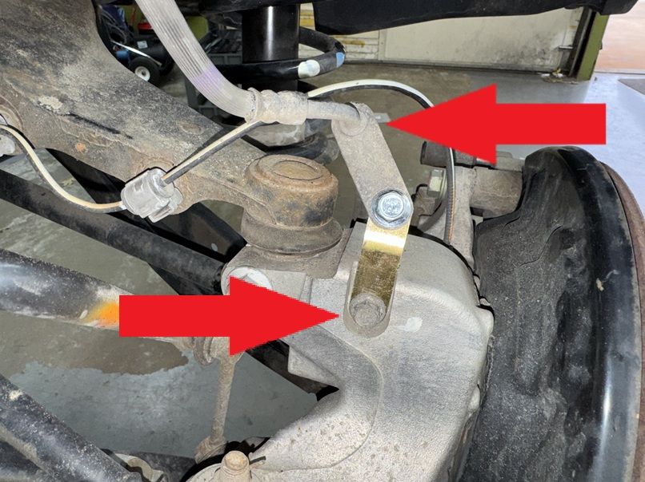

Step 31. Double check ALL BOLTS!
Step 32. Reinstall wheels and lower vehicle.
Step 23. Reinstall interior panels and cargo liner.
Step 33. Get a professional alignment.
Step 34. Find some trails!!

Troubleshooting noises after the installation:
- Rattling from front while going over bumps: Check sway bar end link nuts. Most common cause.
- Rattling from rear while going over bumps: Check sway bar mounting brackets. Be sure all bolts are tight.
- Creaking while driving either front or rear: Check subframe bolts.
- Scraping noise while driving: Check brake dust shields. Bend away from brake rotors as needed.
- Engine sounds louder than usual: check dog bone bolts. Loosen and re-tighten.
Note: Installing lift spacers will change the suspension geometry and will require a 4 wheel alignment.
Warning: Failure to follow the procedures in these installation instructions may result in unsafe handling characteristics, damage to vehicle, or loss of control.
For tech support, please call 1-844- HRG LIFT (474-5438) from 8-4:30 PM EST Mon-Thu 8-3:30 PM Fri or email us 24/7 at support@hrgoffroad.com.
This product is intended for off-road use only!!
Copyright HRG Offroad 2026

2019-2024 Subaru Forester and Forester Wilderness 2.5" lift kit
Checklist:
__ OUT2024 2.0F(1L,1R)
__ FOR0913 2.0R (2)
__ FOR9808 SHIM (2)
__ 1.0 SSE (1) steering shaft extension 3 m6 set screws
__ Bent BLBL (1L, 1R)
__ Bent BLB2 (1 pack)
__ 4 1.25x1 M12
__ 6 1.25x1 M14
__ CRO24+RSBRB (2)rear sway bar relocation brackets. 2 m8x16 2 m8 nuts per
__ FOR19-24 VHRB (1) vacuum hose relocation bracket m6x16, m6 nut
__ 2.75x2 M14 (4)
__ 1x2 M10 (4)
__ 1x1 M10 (8)
__ 0.75x.5/M8x25 (1 pack of 4)
BOLT PACK
__ M12x140 (4)
__ M14x135 (2)
__ M14x200 (4)
__ M14x50 (4)
__ M10x70 (6)
__ M10x50 (6)

